

SCHOOL *of* BUSINESS AND TECHNOLOGY

Department of Engineering and Aviation Sciences

**Satellite Image Analyzing App to Perform Crop Health Predictions**

**Timothy Riley Jr**

Advisor: Dr. Zhang

November 25 , 2021

Satellite Image Analyzing App to Perform Crop Health Predictions

By

Timothy Riley Jr

Submitted to the Department of Engineering and Aviation Sciences in partial fulfillment of the requirements for the degree of Bachelor of Science in Engineering at the

UNIVERSITY OF MARYLAND EASTERN SHORE

Date 05/13/2020

The author hereby grants the University of Maryland Eastern Shore permission to reproduce and distribute publicly, paper and or electronic copies of this document in whole or in parts.

Authors Timothy Riley Jr

Signature

Date 05/13/2020

Department of Engineering and Aviation Sciences

Certified by

Special notice for formatting for the whole report:

1. Keep the formatting consistent (learn and apply the MS ‘Styles’ in formatting). Do not change any format but just apply corresponding styles as listed.
2. Do not add any blank rows but use BREAKS, except the end of a table. BREAKS can be found on ‘Page Layout’ → ‘Page Setup’ → ‘Breaks’.
3. Every figure or picture must be mentioned in the text first then can appear. When it is mentioned, use the cross-reference.
4. Every figure or picture in the text must be accompanied with the caption and detailed description.
5. Only third person is allowed (except the Conclusion and Acknowledge sections). Never use ‘we’, ‘our’, ‘you’, etc. anywhere else (use the ‘find’ function of MS Office to double check).
6. Use ‘do not’ other than ‘don’t’, and so forth.
7. You can copy any reference information from anywhere, but anything not from yourself must be refereed and the original information must be included in the Reference section.
8. The reference must be organized with professional software such as ‘Endnote Web’, ‘Mendeley’, etc. Use IEEE reference format.
9. Try Grammarly. It can help in fixing typos and grammar errors.
10. If you get ‘Styles’ messed up, the easiest way is to start over, to open this blank template and copy-paste contents into it.

List of Contents

Table of Contents

List of Contents 4

List of Figures 2

List of Tables 2

Abstract 2

Chapter 1. Introduction 2

Background/Motivation 2

Objective 2

Design Requirements 2

Design Constraints 2

1.1 Design Constraints 2

Design Method (Approach) 2

Standards 2

Chapter 2. Project Description 2

System Description 2

System Diagram 2

System Functions 2

Chapter 3. Implementation Plan 2

Tasks 2

Team Organization 2

Timeline/Milestones/Delivery Plan 2

Chapter 4. Implementation 2

Implementation of Task 1. 2

1. Implementation of Subtask 1.1 2

2. Implementation of Subtask 1.2 2

Implementation of Task 3. 2

4.1 2

4.2 2

3. Implementation of Subtask 3.1 2

4. Implementation of Subtask 3.2 2

5. Implementation of Subtask 3.3 2

Implementation of Task 2. 2

4.1 2

6. Implementation of Subtask 2.1 2

Chapter 5. Project evaluation 2

Chapter 6. Conclusion 2

Acknowledgment 2

Appendix 3

A. Source Code. 3

1. Source Code of producing polygonal boundaries of field sites: 3

2. Source Code of importing and creating map layer of Sentinel-2 image dataset 3

3. Source Code of Clipping image data to field boundary 3

4. Source Code of extracting pixel band values 3

5. Source Code of linked map UI 3

6. Source Code of extracting excel sheet data 3

REFERENCES 3

List of Figures

Figure. 1. Figure 1: Pesticide spraying device 5

Figure. 2. Figure 2: Canola species of cover crop 5

Figure. 3. Figure 3: Earth Engine Application for analyzing Amazonian fires in Bolivia 6

Figure. 4. Figure 4: System Diagram 8

Figure. 5. Figure 5: image taken of a singular field quadrat. 12

Figure. 6. Figure 6: Description of the layout of the web based IDE for Google Earth Engine. 13

Figure. 7. Figure 7: Zoomed in display of two boundaries from the field site data 14

Figure. 8. Figure 8: Representation of the band values corresponding to a random pixel in the Sentinel-2 image collection. 15

Figure. 9. Figure 9: Satellite image clipped to two field site boundaries. 15

Figure. 10. Figure 10: Array of pixel band values from field sites. 16

Figure. 11. Figure 11: Excel spreadsheet of metadata recorded from multiple quadrants of the Bradbury field site 16

Figure. 12. Figure 12: Prompt from Earth Engine code asking for field data name. 17

Figure. 13. Figure 13: Basic UI for location finding functionality 18

Figure. 14. Figure 14: Display of linked map UI 19

Figure. 15. Figure 15: Example of a decision tree flow chart. 21

Figure. 16. Figure 16: Visualization of a random forest regression model 21

List of Tables

Table 1. Project Timeline and Delivery Plan 10

Abstract

By the end of the project, summarize the project into short text and put here (can be waived for Senior Design I). The abstract needs to be more than half page.

This design is a combination of machine learning algorithms with remote sensing data on a geographical information systems platform. Producing a web based application capable to

1. Introduction

This project will be the development of a web application in Google Earth Engine that performs plant health predictions on satellite images. The web application will implement a trained machine learning algorithm that predicts the biomass and percent of nitrogen from a satellite image of plant life. The algorithms predictions will also be converted into a raster map by the application and presented to the user interactively.

## Background/Motivation

Modern agriculture today operates far differently than that of decades before due to the various advancements in technology like sensors, devices, machines, and information technology. Today’s agriculture routinely uses sophisticated technologies such as robots, temperature and moisture sensors, aerial images, and GPS technology. These advanced devices and precision agriculture and robotic systems allow businesses to be more profitable, efficient, safer, and more environmentally friendly.

With the rise in the application of artificial intelligence technologies in multiple industries globally, it is beginning to make its mark in the agriculture industry as well. Farms produce hundreds of thousands of data points on the ground daily. With the help of AI, farmers can now analyze a variety of things in real time such as weather conditions, temperature, water usage or soil conditions collected from their farm to better inform their decisions. For example, AI technologies help farmers optimize planning to generate more bountiful yields by determining crop choices, the best hybrid seed choices and resource utilization. AI systems are also helping to improve harvest quality and accuracy -- what is known as precision agriculture. Precision agriculture uses AI technology to aid in detecting diseases in plants, pests, and poor plant nutrition on farms. AI sensors can detect and target weeds and then decide which herbicides to apply. This helps to prevent over application of herbicides and excessive toxins that find their way in our food. A visual example of a pesticide spraying robotic device is shown in figure[1]. All approaches to AI in agriculture have the same overarching goal, to quantify factors leading to crop health for the farmers benefit and therefore the consumers benefit.

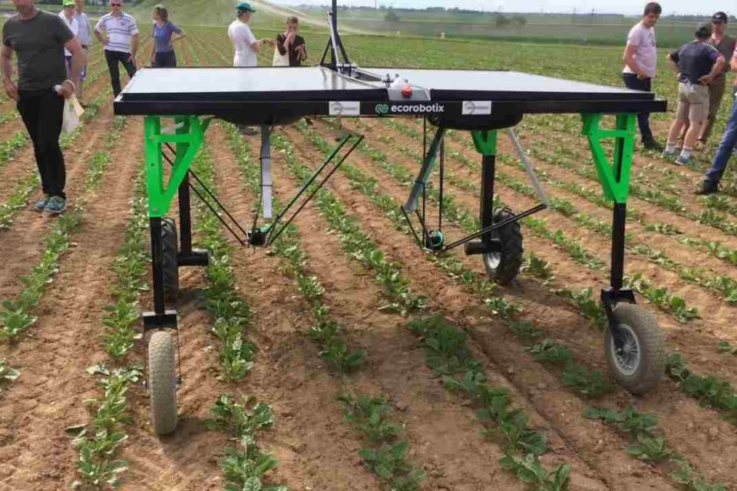

Figure 1: Pesticide spraying device

Plant health can be quantified in different ways like, presence of diseases, crop growth over time, or color. A very common way to determine a crops health is to look at its biomass content and its percentage of nitrogen in the soil.Biomass and nitrogen content are essential factors to the growth and sustainability of plant life. Biomass is the weight of living plant material contained above and below a unit of ground surface area. A greater biomass content translates to more abundant plant life and health. Nitrogen is a key component of chlorophyll and directly affects photosynthesis. Photosynthesis is the process of converting sunlight into energy for growth of the plant. Monitoring and assessing the content of both factors is critical in ensuring the wellbeing of the crop. It is well known by Agriculturists (farmers) that cover crops enhance the quality of crop production. One of the important benefits of cover crops is their impact on soil nitrogen cycling. The cover crops will trap excess nitrogen that would normally runoff, into the soil. The cover crop also produces more nitrogen for the crop it is growing beside for when levels of nitrogen normally decrease during the year. An example of a cover crop is shown in figure [2].

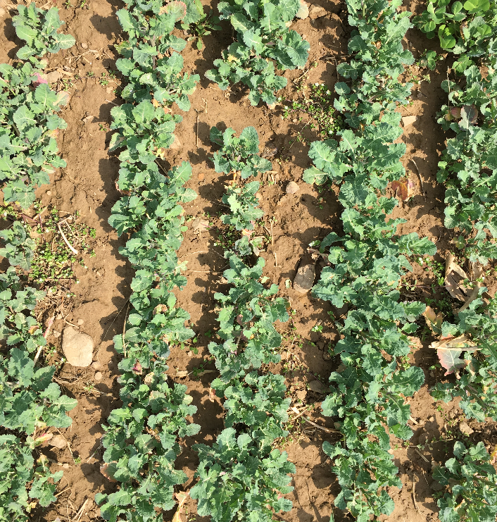

Figure 2: Canola species of cover crop

.Many research projects are underway on this topic of using cover crops to control nitrogen levels by multiple agencies such as the USDA. The Demand for sensing and analyzing the data needed for the topic is very high but difficult to achieve due to the large scale on which farm/ field sites operate. There is data supporting that plant health can be measured from advanced imaging such as near-infrared reflectivity. Research has previously been conducted using a handheld NVDI meter to estimate levels of biomass nitrogen content in different cover crop species (White, Bradley, Finney, Kaye, 2019). Results of this estimation process were generally successful with predicting biomass nitrogen content from multiple species of cover crops and achieving over 75% confidence in predictions. This faucet though doesn't add much scalability or ease of use to the user as they must take the predictions themselves at different spots around their field with the device.

Satellite image processing has become significantly improved and accessible in recent years. This has led to its ideal use in applications that analyze large regions of geographical data. A large part of this movement was caused by the introduction of Google Earth Engine. An example of analyzing an area of land on earth's surface using Earth Engine is shown in Figure [3].

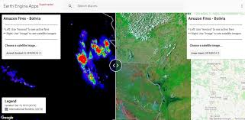

Figure 3: Earth Engine Application for analyzing Amazonian fires in Bolivia

With the use of satellite imaging major areas can be analyzed quickly and efficiently. An entire field can be processed within minutes. This saves the farmer a great deal of time in analyzing their crops and assists in up-keeping the health of the field.

## Objective

To deploy a web application through Google Earth Engines (GEE) API that analyzes satellite images and produces raster mapping of plant health, in the form of biomass content and percent nitrogen predictions.

## Design Requirements

1. Perform regression on pixels to obtain predictions of biomass & nitrogen content with at least 90% accuracy
2. Access satellite images from coordinate inputs.
3. Display results of biomass and nitrogen content as a raster map layer on top in the Earth Engine API
4. Provide an interactive user interface with the Satellite Map

## Design Constraints

## Design Constraints

1. Web application must be written in Google earth engine Javascript API.
2. Accessible data is determined by images taken by the constellation of Sentinel satellites and field data taken from field sites by the USDA
3. Pixel resolution of sentinel images is accurate down to 10 m by 10 m area.

## Design Method (Approach)

The first step to accomplish design requirements is to analyze and organize the data from satellite images and excel spreadsheets. Organizing consists of assigning coordinates and labels to every element in the dataset. The second step is to write the source code for an Alpha version of the Google Earth Engine app. Which is just a basic script for the base functionality of the application to be built upon. The third step is to preprocess the data into training and validation datasets for Tensorflow. The fourth step is to build and train a machine learning model in Tensorflow with the dataset. The fifth step is to improve model accuracy by analyzing prediction results and modifying the structure of the model then training again to see new results. The sixth step is to add backend integration to the application that combines the prediction algorithm with the satellite image data. The seventh step is to improve the User interface code and workflow of the application.

Achieving proper functionality from the application system can be simplified into ensuring these 5 major technical processes operate correctly and uniformly: Satellite Image Interpretation, Plant health interpretation, Machine Learning Algorithm, Earth Engine User Interface (UI), Earth Engine backend script. Each major process holds multiple tasks leading to a section of script to be written in Javascript. In the end these scripts will be implemented on top of the basic application code to each provide a crucial component to the functionality of the final product.

## Standards

N/A

1. Project Description

In this section, you are going to add more details of 'what' and answer the question 'how'.

## System Description

The system is a Web application accessible via web browser and served through Google’s Cloud Computing services. The backend of the application including its neural network will be written in python and the front end User Interface (UI) will be written in Javascript. The User Interface for the application is accessed through Google Earth Engine website. The User interface will show the most recent imaging from the Sentinel II satellite and will have a prompt asking for a location. Once requested the application will capture an image of that location then utilize a neural network to process the image to predict the Biomass content and nitrogen % of every pixel of that image. That vector data is transferred to raster mapping and presented to the UI for the user to evaluate. Figure 4 shows the system diagram for the flow of the application.

## System Diagram

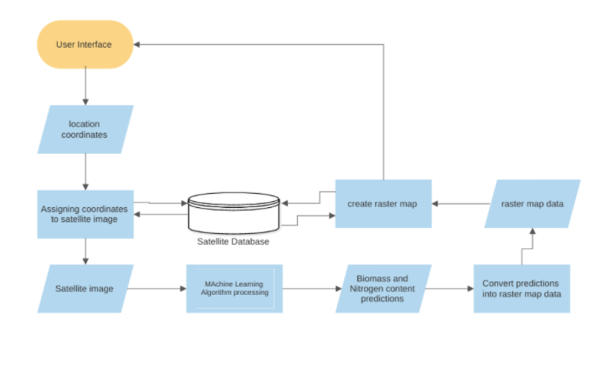

Figure 4: System Diagram

## System Functions

1. When the user goes to the link of the Google Earth Engine app, satellite imaging is shown and can be interacted with to view different areas of the world.
2. Application prompt is displayed on the user interface (UI) asking for location coordinates
3. Application prompts the user to specify the dates of images intended to view
4. When coordinates are given to the prompt the application accesses the Sentinel-II satellite image database and directs the UI to show the corresponding coordinates submitted.
5. ‘run’ button is used to begin prediction processing.
6. Application processes the satellite images of the location displayed then utilizes the machine learning algorithm embedded in the code to produce predictions on plant health.
   1. Application breaks down the image pixel by pixel and performs prediction analysis on each pixel to obtain values of biomass and percent nitrogen.
7. The Application takes those prediction values and converts them into mappable raster data
8. The raster map data is associated with the pixel locations of the original image and a raster map layer is produced on the output map
9. The UI is now updated and prompting the raster map data and legend where the areas of good plant health and bad plant health were predicted to be.
10. The UI also shows options to save/download dataset images of the original satellite image and the raster map image.
11. Implementation Plan

* Task 1. Preprocessing the Dataset
  + Subtask 1. isolate necessary information from satellite
  + Subtask 2. isolate vital information from field site data
  + Subtask 3. Correlate quadrat data to pixel location in satellite images
  + Subtask 4. Create a Training Dataset
* Task 2. Building Machine Learning Model workflow
  + Subtask 1. Prepare Dataset for the Biomass and Nitrogen Prediction models
  + Subtask 2. Build the Random Forest Regressor (RF)
  + Subtask 3. Train the Biomass and Nitrogen RF models
* Task 3. Collecting and analyzing Results
  + Subtask 1. Analyze performance metrics
  + Subtask 2. Collect initial Random Forest training results from each model
  + Subtask 3. Prepare refinement plan to improve results
* Task 4. Execute refinement plan and produce improved models
  + Subtask 1. Implement primary refinements
  + Subtask 2. Test Refinement performance and troubleshoot
  + Subtask 3. Implement secondary refinements
  + Subtask 4. Test secondary refinement performance and troubleshoot changes
  + Subtask 5. Implement final refinements
  + Subtask 6. Assess final refinement results
* Task 5. Perform Preliminary Tests
  + Subtask 1. Make final evalution of the Random Forest models
  + Subtask 2. Combine the data processing and model defining code
  + Subtask 3. Make final alterations to base code
* Task 6. User Interface Elements
  + Subtask 1. Define Application layout
  + Subtask 2. Add interface to outline test site
  + Subtask 3. Add visual maps for each prediction
  + Subtask 4. Test the application functionality

## Team Organization

Timothy Riley is the sole team member responsible for all tasks and subtasks in completing this project.

## Timeline/Milestones/Delivery Plan

1. Project Timeline and Delivery Plan

|  |  |  |  |
| --- | --- | --- | --- |
| Time | Task | Comments | Responsibility |
| week 1 | Start task 1.1 | read and extract satellite images of field locations |  |
| week 2 | Start task 1.2 | organize biomass and percentage nitrogen from field level data |  |
| week 3 | Start 1.3 | correlate field level data to pixel locations in satellite image |  |
| week 4 | Start 1.4 |  |  |
| week 5 | Complete 1.3 | Build Dataset input pipeline |  |
| week 6 | Complete 2.1 | Build ML algorithm structure & begin training |  |
| week 7 | Start 2.2 | Collect results from initial training then start revision process [5 weeks needed] |  |
| week 8 | Continue 2.2 | revise structure or parameters of the algorithm |  |
| week 9 | Continue 2.2 | initiate training again and repeat process |  |
| week 10 | Continue 2.2 |  |  |
| week 11 | Continue 2.2 | achieved accuracy of 90% is ideal |  |
| week 12 | Start 5.3  Complete 3.1 | write Google Earth Engine app that can access the Sentinel II satellite database interactively |  |
| week 13 | Start 3.2, 3.3 | add functionality to capture image of a location when coordinates are given |  |
| week 14 | Complete 3.2, 3.3 |  |  |
| week 15 | Start 4.1, 4.3, 4.2 | write the code that breaks down the captured image into a pixel array |  |
| week 16 | Finish 4.1, 4.3 | Associate each pixel with a value representing its location |  |
| week 17 | Continue 4.2 | integrate Machine Learning algorithm into the App code (takes pixel as input and outputs prediction values) |  |
| week 18 | Finish 4.2  start 5.1, 5.2 | Convert prediction values into mappable raster data |  |
| week 19 | continue 5.2 | use pixel location values and raster mp data to draw raster map over the captured satellite image |  |
| week 20 | Continue 5.3 | add more user interface features to view and download the raster map image and data results from the algorithm |  |
| week 21 | Finish 5.3 | perform final user testing then deploy application to Google Earth Engine platform, finalize system and documentation |  |
| week 22 | Task 6 | Analyze application performance and conduct final redesigns |  |

1. Implementation

The pages that follow will highlight the processes completed, tools used, and skills gained for proper execution of the tasks at hand defined in this project's scope. The major services and tools used and referred to in the task implementations as as follows:

* Google Earth Engine: a cloud-based platform for planetary-scale environmental data analysis.
* Google Collaboratory: Colab is a free Jupyter notebook environment that runs entirely in the cloud.
* Tensorflow: a Python-friendly open source library for numerical computation that makes machine learning faster and easier
* Python: an interpreted, object-oriented, high-level programming language with dynamic semantics.
* Javascript: a scripting or programming language that allows you to implement complex features on web pages.

Completion of the Earth Engine plant health prediction app is dependent upon 5 major technical areas working together; the satellite image processing interpretation, the field level data processing interpretation, the machine learning algorithm, the Earth Engine application User Interface (UI) and the Earth Engine javascript back end code. Work on the first 4 areas is being progressed separately and will be added to the 5th area systematically.

.

## Implementation of Task 1.

Task 1 is vital to the training of the machine learning model because it provides the algorithm with a clear and informative dataset for the model to learn from.There are two parts to the dataset used for training, the satellite images and the plant health metrics (quantifying Biomass content and percentage of nitrogen). The dataset information was obtained from USDA operatives conducting research on quantifying cover crop abundance and other metrics in various fields. The data was sent to me having this initial structure:

Plant health metric data:

5 field sites

3 treatments per site

8 quadrats per treatment

-data sampled twice for each quadrat

-each quadrat is 0.5 m by 0.5 m

- data sampled is of biomass content and % nitrogen taken from soil

An image of the area a quadrat represents can be seen in Figure 5 below.

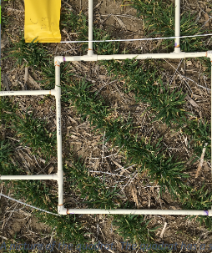

Figure 5: image taken of a singular field quadrat.

Satellite imagery data:

5 field sites

7 field geometric outlines

*pixels present in each geometric outline is to be determined*

The data is taken from multiple field sites in Maryland. The satellite images will be analyzed in Google Earth Engines API which has access to the Sentinel-2 surface reflectance image database. The Sentinel-2 satellite is a wide-swath, high-resolution, multi-spectral imaging mission. This satellite monitors vegetation, soil and water cover, as well as observation of inland waterways and coastal areas.

### Implementation of Subtask 1.1

The open source coding platform, Google Earth Engine allows for free extensive use and manipulation of satellite imagery from petabytes of satellite image datasets which are all accessible from their remote databases. Access to the multitude of satellite imagery is available through use of the Earth Engine API. An API is an Application programming interface consisting of a set of tools and protocols used for building software applications. The Earth Engine online code editor is a web based Integrated Development environment (IDE) that utilizes the Javascript API to design and publish applications. A description of the multiple elements within the Earth Engine online IDE can be seen in Figure 6. Reading and understanding the operation of the Earth Engine IDE was critical in manipulating the satellite image data properly.

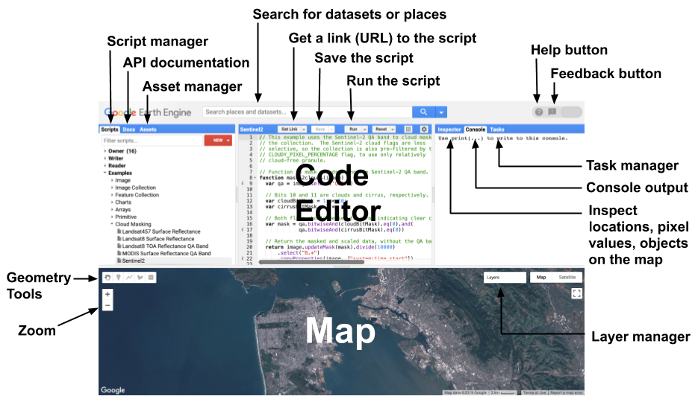

Figure 6: Description of the layout of the web based IDE for Google Earth Engine.

Figure 6 displays the Earth Engine web IDE. The figure labels the base features and layout of the code editor. The API for the online code editor is in Javascript programming language. The obtained dataset for the satellite imagery is in the form of field boundary shapefiles which hold location coordinates for the various sites. The boundary shapefiles can be uploaded and interpreted by the code editor as a feature collection. There are two major datatypes within Earth Engine, the first is feature data and the second is image data.

Features refers to any ….

The feature collection created from the shapefiles held the boundary coordinates of 7 polygons representing the location and area of 7 fields from 5 research sites ( some sites have multiple bounded areas). In order to view the satellite images specific to multiple field sites, a file of assets that hold polygons corresponding to the field site coordinates was uploaded to the Earth Engine console as the feature collection. Then the feature collection was converted into a map layer displaying the polygonal boundaries of the 7 sites on the map. Code for this process can be viewed in **section A1** of the appendix.

The result produced is zoomed in on the Kennyville site in the map of figure 7.

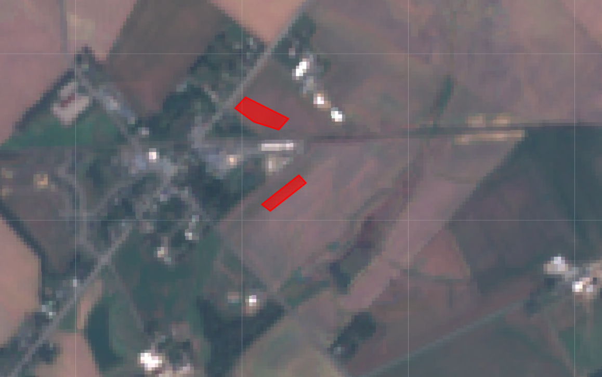

Figure 7: Zoomed in display of two boundaries from the field site data

The red polygons represent the geometry of the field sites where the data for the biomass and percentage of nitrogen was taken from quadrats on those fields. Data in Earth Engine is represented in two main ways, features or images. A collection of feature data was used to draw polygons of the field site locations as a layer in the map. Images in Earth Engine are a stack of Georeferenced bands each with their own mask projection and resolution. the images are represented in arrays of pixels that each hold the band values for the location the pixel represents. The Sentinel-2 surface reflectance database consists of a collection of images dating back to 2017. Each image holds 16 bands of information and each band records reflectance at a different wavelength and resolution. That value is then recorded and assigned to the pixel’s coordinates it is belonging to in the Sentinel-2 imaging dataset. Shown in figure 8 is an example of the band values for a random pixel manually inspected in the Earth Engine code editor (in both bar graph and list format):

Figure 8: Representation of the band values corresponding to a random pixel in the Sentinel-2 image.

The objective of Subtask 1.1 is to accurately quantify the band values of the pixels within the 7 field site boundaries and have them correlate with the pixels specific geographic coordinates. To accomplish this the Satellite imaging data had to be cut to provide values only within the boundaries of the field site polygons. The function, ‘clipToCollection’ was useful in producing new map image bands only within the field site boundaries. The source code for this process can be seen in **section A3**  of the Appendix. The map output is shown in figure 9.

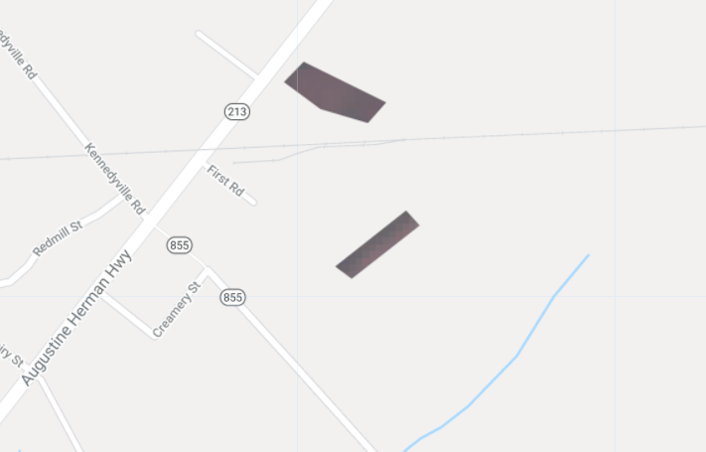

Figure 9: Satellite image clipped to two field site boundaries.

Next the band value metadata of the visible pixels had to be extracted and associated with appropriate location coordinates. The code for extracting pixel data from images in a boundary can be viewed in **section A4**  of the Appendix. The result from the code is an object with arrays of elements each corresponding to a pixels band value as shown in figure 10.

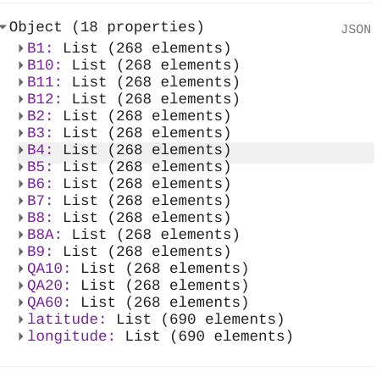

Figure 10: Array of pixel band values from field sites.

The final step is ensuring the coordinates of the pixels match with the band values which will take further investigation in the API to complete.

### Implementation of Subtask 1.2

The second half of the data needed for training a machine learning model is the label data or in this case the values of the biomass and % of nitrogen taken at ground level at the specified field sites. The original data was obtained from the field in the form of quadrats as shown in figure 5. The quadrats dimensions are 1m by 1m. The metadata from the quadrats were recorded into excel files and organized like in the sample figure 11.

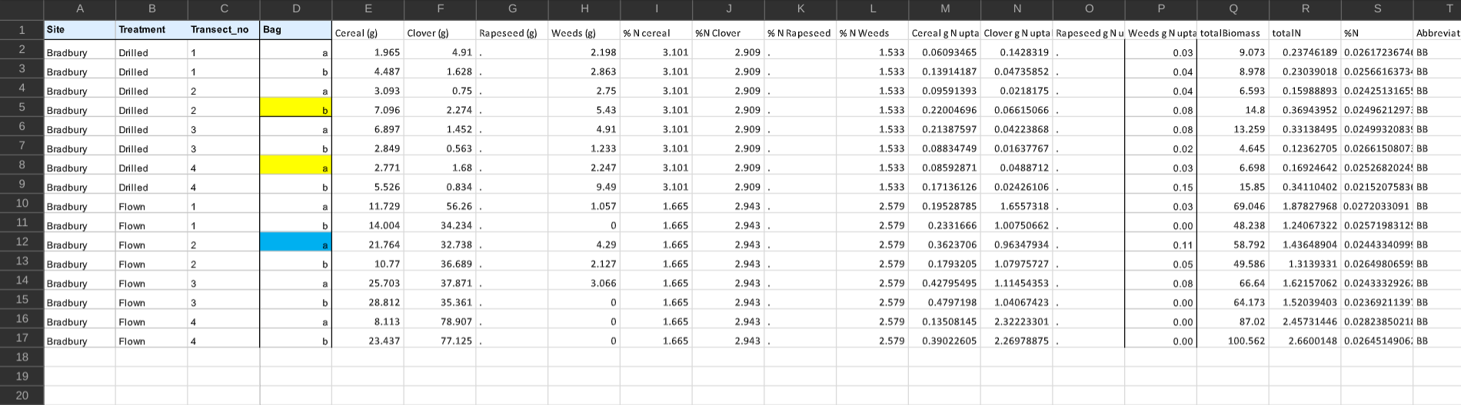

Figure 11: Excel spreadsheet of metadata recorded from multiple quadrants of the Bradbury field site

Figure 11 shows that there were many values obtained from the analyzed quadrats but most of which were focused on seeding rates of the different cover crop species. The main pieces of data vital to this task are the ‘totalBiomass’ , ‘totalN’ , and ‘%N’. Data in excel format can be extracted and interpreted many ways but an efficient tool discovered was the **openpyxl**  library which manipulated excel data in python. This was ideal when trying to use this data with a tensorflow model. The issue that arose in this task was that the quadrat data wasnt scalable enough to correlate to the much larger satellite image. Field quadrats cover an area of about____by ___. Various quadrats spaced at multiple points across a field capture the diversity in vegetative metrics over a large agriculture plot which covers several hundred square meters. This drawback of this field level sampling process is that is take a vast amount of time to precisely capture the vegetative metrics and accumulate this data with proper metadata properties such as the geospatial corrodinates of each quadrat.

Proper metadata is essential in geo spatial analysis, irregular or missing metadata can cause major errors in perfroming deep analysis. This in effect causes the labeling and accumulation process for field level quadrat data quick pain staking and methodical.

The sentinel-2 images obtain band data down to 10m x 10m pixels which still allows for a large room of misinterpretation of field data. The researchers at USDA are currently in the process of upscaling this field level data to correlate with the distance of sentinel 2 imagery. Ensuring that the field level data is robust and concise requires time so major sections of code were developed while the data was accumulated.

*************Skip to re

Importing field level data was the first major undertaking for preprocessing a training dataset. Geospatial data is transferred and processing in many different formats. As Stated in Task 1.1 there are two major formas of data objects within GEE, features and Images. Features hold metadata information about locations and values while images hold geo spatial information containing satellite band related data.

The usable format of this field level data is of shapefiles which are….

GEE allows for some common geospatial related data formats to be upload to the GEE server and converted to feature collections or image collections for GEE projects. In this case the field level data as shapefiles can be uploaded as shown in figure ____. Once uploaded the data is held in the “cloud Assets directory the feature collections can be imported to a GEE script file as shown in figure___

To develop the code for preprocessing quadrat data into a GEE map a synthetic dataset was produced that mimics the organization of actual field level data. The data files for this synthetic dataset was uploaded to GEE and processing began.

The synthetic dataset consists of __ simulated quadrats. Once the shapefile is imported as a feature collection to a new script the polygonal outlines for each quadrat is presented on the map using the Map.add function implemented in code section…. The location of these quad boundaries can be viewed centered and inspected as shown in fugure … each quad polygon holds the metadata for the average biomass and nitrogen content within that quadrat. ***[check GEE **organizing synthetic data for displaying quadas and sent data ]**

### Implementation of Subtask 1.3

Once quadrat data and satellite data are accessed and displayed together in a combined script the next step in the preprocessing workflow is to correlate sentinel 2 image bands with the locations of each field data quadrat. The goal of task 1.3 is to have band data associated with the location of the filed level biomass an nitrogen data together in a single collection.

The first effort was set to obtaining the exact coordinates for each quadrat. By using the centroid.geometry() method, the center point of each quadrat polygon could be assessed, this way a clear point to align with sentienl pixels is determined. These center point values are to be collected and used to match a sentinel pixel in a separate function.

When enacting this process it can be shown as in figure____ that the output from the centroid process is a list of the quadrats with center point locations at elements in the list. This causes a problem with enacting the second objective of linking the point locations with sentinel pixels.

In GEE iteration loops are performed through the ‘.map’ module which runs through all features in a feature collection, obtaining all metadata properties of the feature at each iteration. The key here is that a feature collection must be the object that the “.map” is applied to. This leads to the restructuring of the band extraction process. The itital process is applied to the 5 major site polygons as shown in figure___. The code created in this intial process (section A__) takes the polygons of the large 5 site boundaries, then uses the reduce regions module to sample points at a specified distance apart within the field bounds and accumulates the band values at these points into a featue collection. This process is combined with the centroid.geometry() process within a .map function that, when given a feature collection of quadrats will take each feature element, compute its center point, align its center point with that of a sentinel pixel, extract the desired band values of that pixel and finally export a new feature collection that hads added sentinel band values to the metaproperties of each feature. As shown in figure___ The code for this band extraction function can be found at section___ .

1—synthetic data : find center loc for each quad __outcome : list of data and location properties

- code script file name: **organizing synthetic data**

2—using 5 sites data: use clip and reduce regions to expand on the progress of task 1.1

After clipping those band values can be extracted by using reduce regions

* Add to the orginal 5 field sites code first to show a feature collection is the output
  + Reduce regions samples random points across the boundary
* Script name: exporting pixel values

3—combine both parts to get the bands values for each quadrat

Make new script that takes function from **Train_datagen**

### Implementation of Subtask 1.4

Once producing the function for band extraction from a feature collection this process was applied to the synthetic dataset. Code is expressed in section ____. Figure__ shows the map display of the synthetic quadrats and Figure__ shows the output from the band extraction function.

Once the band extraction is applied, the new feature collection is to be exported to be processed in a different script. Using the Export.toAsset module the feature collection can be exported to the GEE personal assets directory this is now represented as a new feature collection holding the same boundary/geospatial location data and but has included the 12 bands data from the sentinel 2A imagery to each boundary element.

## Implementation of Task 2.

Task 2 is the next major step in achieving the design requirements for the application, The Machine Learning Algorithm. Machine learning is an application of artificial intelligence allowing computational systems ability to learn and improve from experiences. A machine learning algorithm is the blueprint that's produced after a system is trained to process data. A system is trained to learn from datasets through models or structures that present the data to the system in various ways allowing the system to find and record patterns in the data to apply to a new set. There are multiple frameworks that employ machine learning and deep learning processes making the training process simpler on the data scientist. In this case a Random Forest Regression model will be implemented within the GEE API.

### Implementation of Subtask 2.2

The purpose of subtask 2.2 is to begin the development of a random forest model that takes band values as input predictor variables and outputs an estimated prediction of biomass content or nitrogen content. The First step in the general process of structuring any machine learning algorithm or deep learning network is defining the problem that needs to be solved. This way the important factors for development are defined like what the output should be and what the success metric should look like. In this case the problem is estimating metrics of biomass content and percentage of nitrogen on a very large scale. The desired success metric for the model should be 85%. The next step is identifying what the specific output of the model would look like, for example most models are for either classification or regression. Classification predictive modeling is the task of approximating a mapping function (f) from input variables (X) to discrete output variables (y). This basically means that the objective of the model is to analyze its input and use its trained weights to create a mapping function that is then used to assign a class or category to that input. Regression predictive modeling is the task of approximating a mapping function (f) from input variables (X) to a continuous output variable (y). [10] This means that the model will utilize its mapping function to quantize the input it is given or a numerical output. A classification output would be something along the lines of color like ‘blue’ or ‘red’ (a label). A regression output would be something like a cost estimation (a quantity). In the case of this design problem, this would need the implementation of a regression model to use inputs from satellite metadata to produce numeric predictions of biomass content and percentage of nitrogen.

The next process in developing a model would be to collect, prepare and preprocess the data. Done properly the quantity and quality of the data will determine how accurate the model can become. A ill preprocessed dataset will hinder the maximum accuracy the model can achieve no matter the qualities of the models structure. The machine Learning model training is dependent upon obtaining the accurate feature(x) and label (y) inputs of a dataset to produce a viable outcome. In the case of this design, the feature (x) input is the satellite pixel metadata/ band values and the label (y) input would be the biomass and % of nitrogen recorded at that pixel. Progress in training the model is halted by the current inaccuracy of the (y) dataset/ field level data. This factor will be solved with the updated and detailed field level data to come from the USDA soon.

This did not restrict development of the model's structure however. Machine learning and Deep learning are the two major subsets of artificial intelligence and each are used to solve ideal objectives. Machine learning is associated with producing algorithms that allow systems to learn how to make decisions or predictions without being explicitly programmed. Deep learning is a subset of Machine Learning whereas it uses machine learning concepts and constructing algorithmic patterns similar to that of the human brain [11]. The result are neural networks that can vary in layers and size but achieve high level understanding from complex data.

The USDA has previously worked on a similar design of a machine learning model that predicts biomass and percentage of nitrogen from hyperspectral drone images. The model algorithm achieved around 83% accuracy and the architecture of the algorithm was permitted to be altered for this design. The proposed Machine Learning algorithm will be a random forest regression model. This is a supervised learning algorithm that randomly creates and merges multiple decision trees into one forest.

Decision trees are a supervised learning method used for both classification and regression tasks. A decision tree is a flow-chart-like structure, where each internal (non-leaf) node denotes a test on an attribute, each branch represents the outcome of a test, and each leaf (or terminal) node holds a class label or estimation. Figure 15 shows a visualization example of a simple decision tree model.

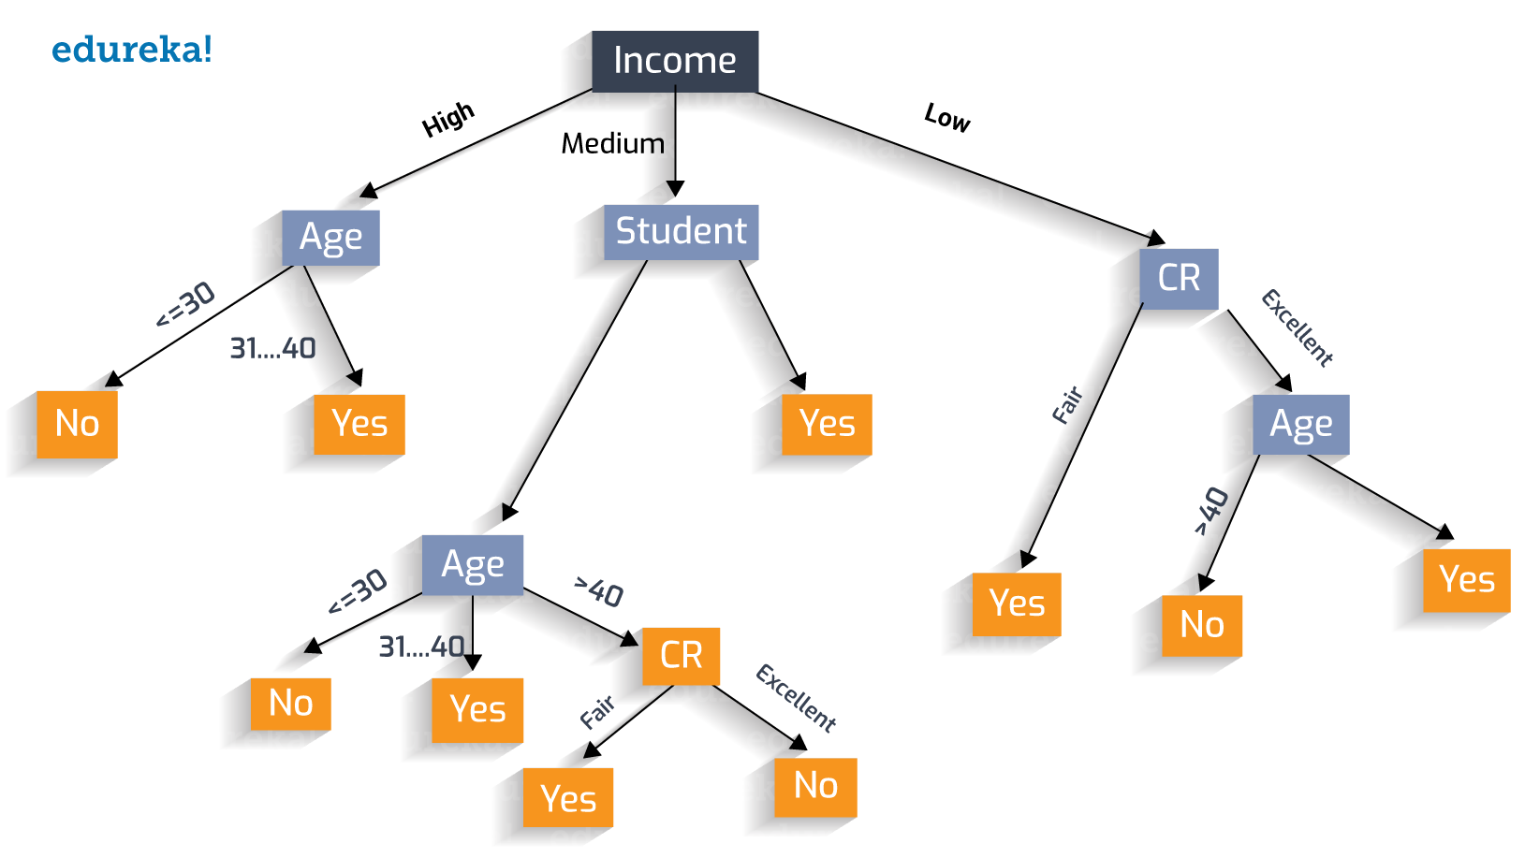

Figure 15: Example of a decision tree flow chart.

Random forest regression is an ensemble tree-based learning algorithm.

Ensemble learning means strategically combining multiple models to accomplish a certain intelligence task. It aggregates the votes from different decision trees to decide the final class of the test object. Regression refers to presenting a numeric output/prediction. Figure 16 shows a conceptual visualization of a Random decision forest model. Random Forests (RF) build on top of the base learner of binary tree method; in RF binary splits recursively partition the tree into homogeneous or near-homogeneous terminal nodes (the ends of the tree). A good binary split partitions data from the parent tree-node into two daughter nodes so that the ensuing homogeneity of the daughter nodes is improved from the parent node [12]. The RF model takes a random subset of the total training variables( features) at the node of each tree and the selected variables are used to split the node. In this way the RF model is grown deeply and reduces bias by adding multiple layers of randomization in training.

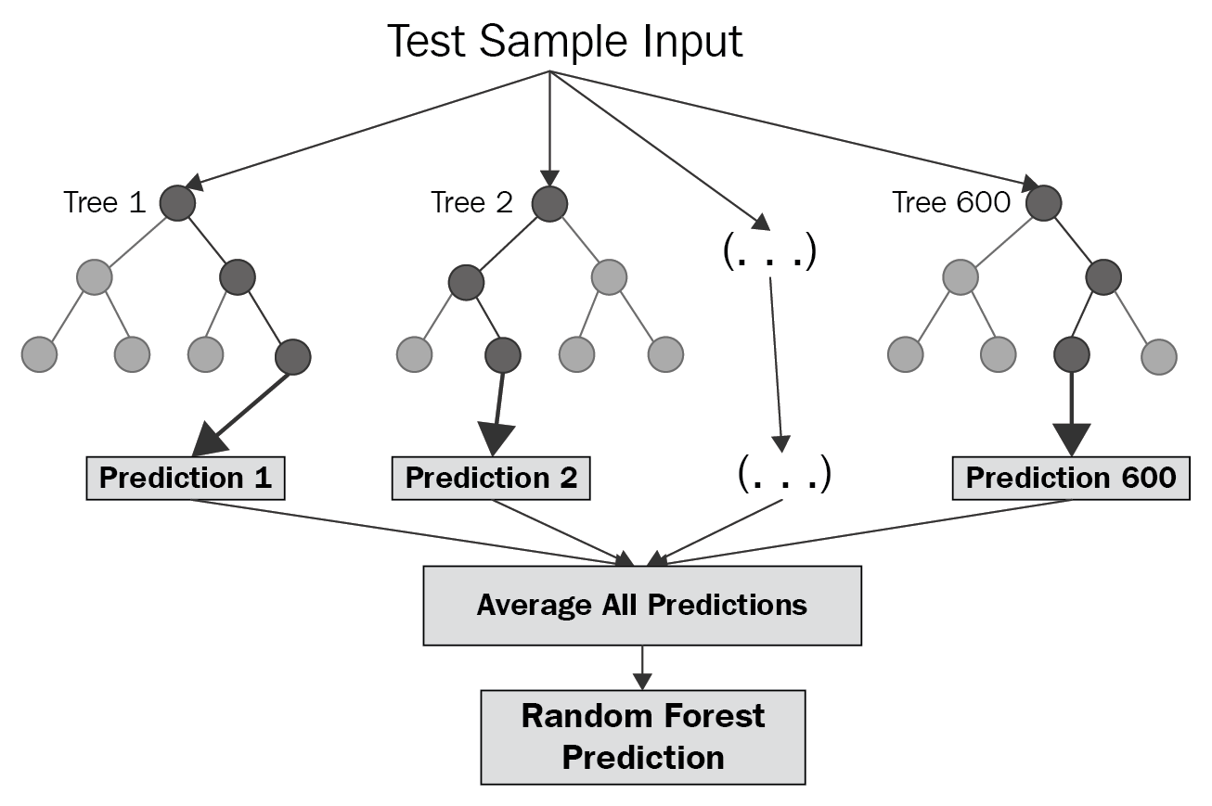

Figure 16: Visualization of a random forest regression model

The first objective of the model design will be to employ a random forest regression model similar to that used by the USDA to predict on the satellite data. The model inputs will be quantized features from the 12 band values extracted at each pixel in the satellite image. The model's outputs will be the average of biomass content and percentage of nitrogen predicted from the multiple decision trees. The structure of this regression model will be a tree ensemble method like that used by the USDA. The model will first construct 300 trees, with number of random variables per split set to 3 and trained on 70% of the quadrat samples then tested on the remaining 30%. Two different Random Forest regressors are to be made, one for estimating Biomass and anpther for estimating Nitrogen content.

Implementing a random forest estimator in GEE is done by the ee.Classifier.smileRandomForest module as show in Figure 17.

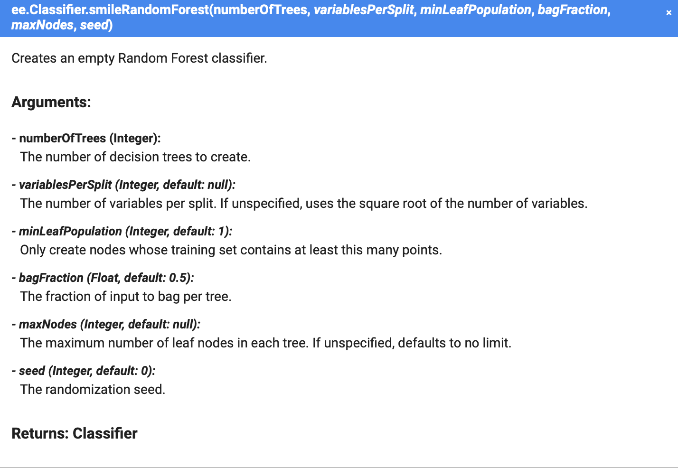

Figure 17: Visualization of a random forest regression model

### Implementation of Subtask 2.1

The process of quantifying, recording and converting field level data at points across a large agriculture field is very methodical and time consuming. This process has delayed the implementation of ground truth data processing up to this point. A small subset of the whole field level data was obtained in the form of a shapefile. The format of the data is identical to that of the synthetic dataset that was explored in task 1. This subset of real field level data is a shapefile with 16 polygons representing the location and size of the field quadrats that were sampled on the Kennedyville farm in Maryland. Each poloygon has metadate with the quadrat name, agriculture treatment description, and crop information of biomass and nitrogen content levels recorded in grams per 0.25 square-meters. While the full dataset of field level data is being collected this subset is used to produce the code for data preprocessing, model creation and intial training results.

The widely used process for any Machine Leanring or Deep Learning project are the following steps:

1. Data collection

2. Data preprocessing

3. Dataset split into train and test

4. Model/Algorithm creation

5. Model Training

6. Trained model applied to test dataset

7. Evaluated results

8. Form conclutions and make adjustments

Task 2.1 involves steps 1 through 3 where the dataset input pipeline is being built. The data that goes into the pipline is the qudrat shapefile and the output from the pipeline should be a dataset with the same number of elements as quadrats from the original shapefile. Each element should have the biomass level and nitrogen content level from the quadrat and the corresponding Sentinel 2 satellite image band values for that quadrat based on its geographical location. The obtained shapefile of quadrat data can be upload to the GEE code editor repository in the same manner as the synthetic dataset. Once fully saved in the asset directory of GEE the dataset can now be imported to a code script as a feature collection. As shown in Figure 18 the data is uploaded by selecting the ‘New’ button, then the feature collection appears in the Asset directory on the left, and finally the dataset can be import for use in the script with the import button.

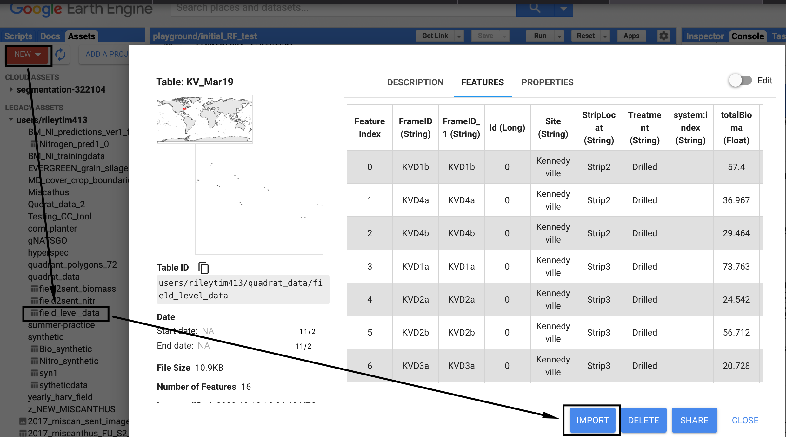

Figure 18: GEE asset directory with uploaded feature collection

Once the collection was imported to this script the code produced in from task 1.4 Section___ will be put to to work in order to combine the field level quadrat data with the sentinel band data. Some minor adjustments needed to be made so that the output is idel for training the RF model. The ‘data’ variable within the code was assigned to the new collection of real field data and the specific names of the biomass and nitrogen variables were added to propList variable. These changes ensured the dataset was extracting the correct field level data and combining with the Sentinel bands. A final line of code was added to the end of the script which uses the *Export.table* GEE module to export the newly create dataset as a feature collection to the asset directory. Completing task 2.1 has resulted in two datasets, one with sentinel bands and biomass values at 16 field points and one with sentinel bands and nitrogen values at the same 16 field points. Thse datasets are to be used with the Random Forest model being constructed in task 2.2.

### Implementation of Subtask 2.3

With the dataset of nitrogen and biomass values preprocessed with sentinel band data, data is now ready to train the random forest regressor model. As stated previously the the ee.Classifier.smileRandomForest module will be used to intiate a Random Forest within GEE. After opening a new script to hold this set of code ( accessible in Section___ ) the two datasets were imported to the script and were randomly split into training and test sets. This is common practice in any Machine Learning or Deep Learning application in order to properly evalute the performance of any model, ‘unseen’ data must be used to test the model. The data was randomly split by 70% for training and 30% used for later evaluation (train and test sets).

The RF module was then called upon and initialized with two parameters, the number of trees to grow and the number of variables slected at each split. After the model is initialized to perform regression with the ‘.setOutputMode()’ function; now the model is ready to be trained and evaluated.

## Implementation of Task 3.

Task consists of evaluation the model in training and testing stages then utilizing results from performance metrics to assess adjustments to be made to improve performance. Once a methodical assessment of current status of the models performance and its caveats, a refinement plan will be produced to implement in Task 4.

### Implementation of Subtask 3.1

A siginicant part of assessing the model is obtaining enough performance metrics from the model evaluation. By default some metrics can be outputted from the Random forest model in GEE right after training. That would be importance and ‘Out of Bag Error Estimate’ , as shown in Figure 19.

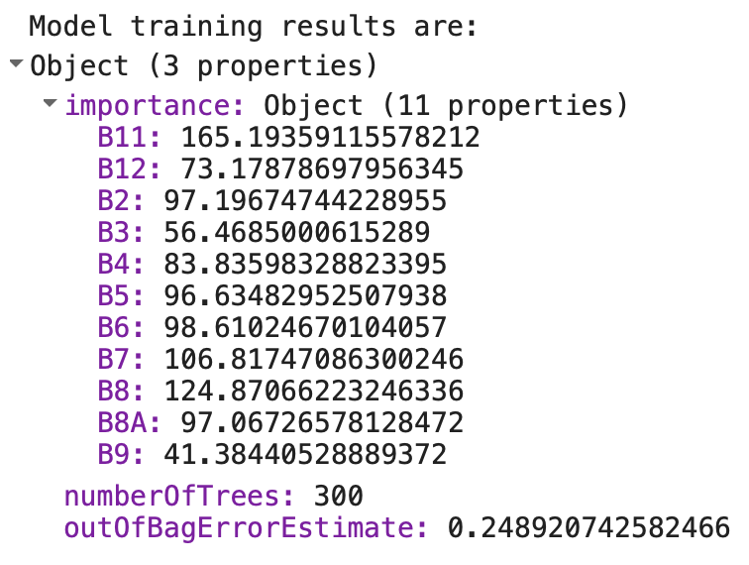

Figure 19: Output from Random Forest Training, importance and OOBE

Importance, also referenced as variable importance refers to the significance that each predictor variable plays in making an estimation from the model. Higher importance values for a variable means that variable is more important in making a prediction than a lower importance valued variable. This output helps identify variables that may not play a large part or any part in making predictions. Typically the importance values sum to 1 and each value is the percentage of importance that variable holds in predictions, but within GEE the importance values do not sum to 1 but are still directly comparable to each other. Out of Bag Error (OOBE) is an average error metric that employs valiadation whilst training the model. Due to Random Frest being an ensemble bootstrap method, during training there are subsamples intiated with differeing training sets per tree. So samples trained on one subset of trained data is then evaluated on data that wasn’t part of that smaple to validate the model mid training. OOBE is the error found in this validation and averged across all the bootstrap samples.

The two metrics explained above are valuable for comparison of training results but evalution for the test set must still be made. Once the trained model is fit to the test set and predictions are made several metrics are to be made. The predicted set was evaluated for root mean squared error (RMSE) and R-squared (R2). RMSE is the standard deviation of prediction errors; it gives a sense of how concentrated the data is around the line of best fit. A lower RMSE means more accurate data. R2 is commonly used in regression analysis as a goodness of fit measure, indicating the percentage of variance in the dependent ariable that the independent variables can explain collectively [13]. R2 is espressed on a scale of 0 – 100% so a higher R2 represents a better prediction.

### Implementation of Subtask 3.2

With traning and evalution metrics implemented into the code the results of the initial test for the biomass and nitrogen prediction models are shown in Figure 20.

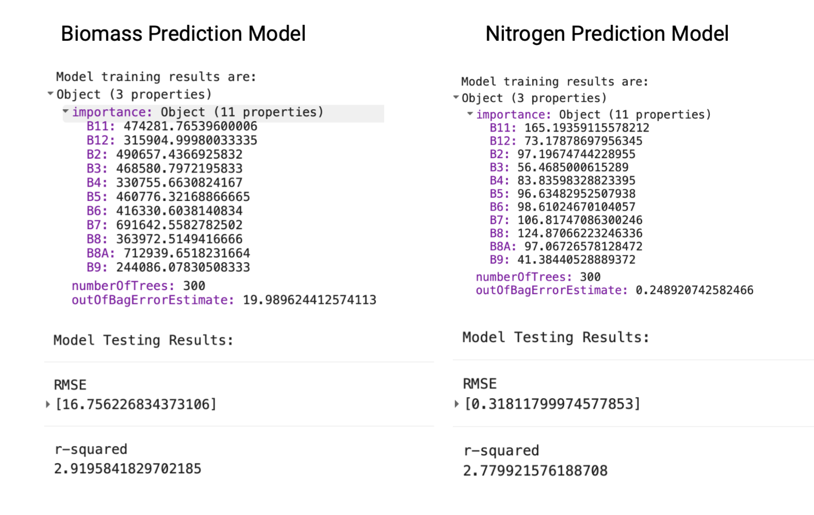

Figure 20: Initial results for Biomass and Nitrogen Models

By reviewing the initial model results, both models showed to be performing very poor in making predictions as according to the R2 values which are 2.92 % and 2.78 % for Biomass and Nitrogen models respectively. For a more in depth evalution a grpahinf module was called upon in the code to visualize the importance values. Also the actual predictions were displayed against the real field data with th percent error for each prediction. These changes are shown in Fgiure 21.

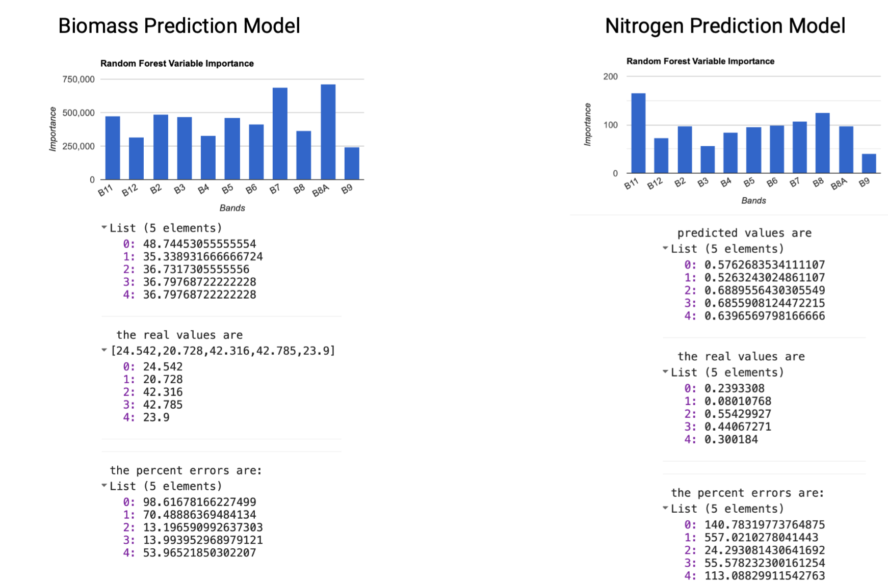

Figure 21: Initial results for Biomass and Nitrogen Models, importance and % error

Figure 21 shows that in the cases of both models they fail to predict much variation in the variable when they shows to be higher variation in the acutal values. The range between max and min values for biomass in the real data is 42.78 and 20.73 whereas the predictions range between 48.7 and 35.3. The disparity in rane is even more evident in the Nitrogen model where actual values range between 0.44 and 0.08 but the prediction values range between 0.68 and 0.52.

### Implementation of Subtask 3.3

The results of the current models were well below the satisfactory mark. There are multiple reasons that could have caused this such as the parameters of the randomn forest aren’t ideal, the predictor variables may be unimportant in making predictions and just adding ‘noise’ to the model, but most apparent of all reasonings is that the dataset is very small. The size and robustness of the dataset makes a significant impact on the performance of a model. With more variability within the data, the model has the ability to form deeper connections between the independent predictors and the dependent variable.

To obtain more insight on the current model performance some minor adjustments to the training workflow were made to possibly negate the lowere level possibilities for the models performance. Several versions of the two models were ran each with a parameter altered in each run. The three parameters adjusted were number of trees, variables per split, and the bands used in training. Three tables were made ( Table 2, Table 3, Table 4)to show the results from adjusting each parameter in increments.

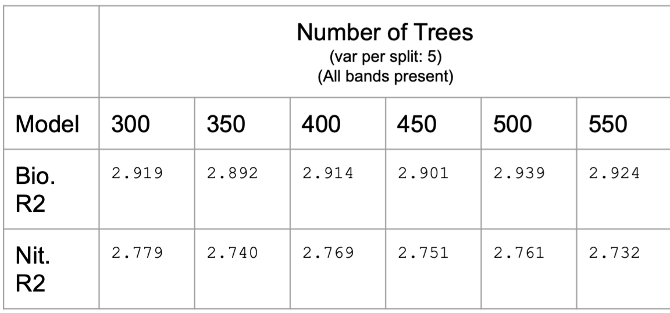

Table 2: Model performance with adjusted Number of Trees parameter

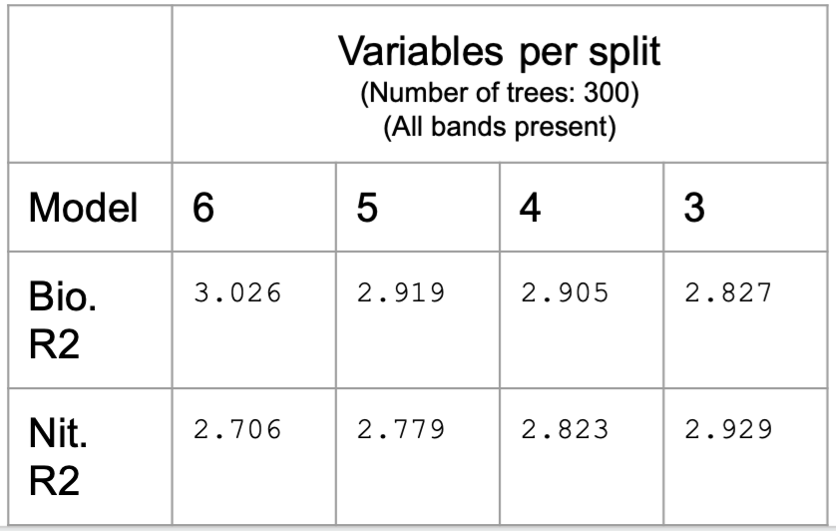

Table 3: Model performance with adjusted variables per split parameter

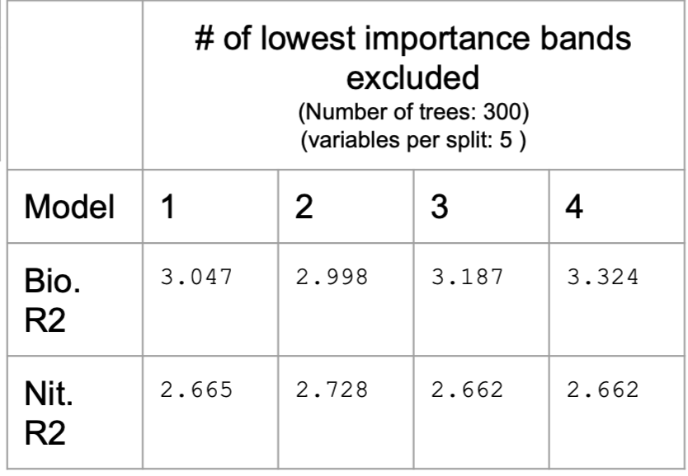

Table 4: Model performance with excluded number of predictor bands

After adjusting the three major parameters for the random forest there was little improvement in the models performance in making predictions. The Highest R2 achieved were 3.324 and 2.929 for biomass and nitrogen respectively. Excluding the number of predictors had the largest affect on the biomass model and increased its performance the most. The modification of these random forest parameters proved to not have a major affect on the performance of the models and obtaining more raw data was dependent upon the USDAs collection time. Therefore a refinement plan was introduced to implement several larger model adjustments.

Refinement 1:

The first refinement to be implemented will be to perform a workaround to maximize the dataset artificially. The proposed solution was a new two-model workflow approach where the small amount of quadrat level data will be upscaled to multiple field level data points giving a vastly larger area to obtain satellite pixel data from. This will be done be implementing the model produced by the USDA which employs hyperspectral drone imagery to predict biomass and nitrogen content. Once predictions are made from the first model there is now a large fields worth of data to be link to the satellite imagery. The sentinel imagery has 10m by 10m pixel resolution therefore across a whole field around 100 data samples can be extracted for training the higher level satellite model.

Refinement 2:

The second refinement is to build on top of predictor variable manipulation as was done in task 3.3. In this case however the number of predictor bands will be increased to possibly assist the model in making assessments of the data. This is done by applying special index formulas which are widely used in remote sensing applications. Indices are a combination of spectral bands computed by unique formulas to make best use of bands senstitve to a certain condition. In the case of this application, vegetation indices were applied to to the imagery to make use of the sentinel bands sensitive to plant vigor [15]. Dozens of indices are applicable using the sentinel 2 bands to highlight key features in vegetation imagery. There is a vast collection of the index formulas available for use provided by Sinergise [14]. Of the collection, the most popular indices such as normalized difference vegetation index (NDVI) and chlorophyll vegetation index will be implemented into the dataset to add extra predictor variables. An assessment of the importance that indices play in making predictions can then be made.

Refinement 3:

The final refinement to be implemented is to obtain the full collection of ground truth field level data from the USDA. This form of training data covers multiple points from a diverse collection of fields. This diversity adds robustness to the dataset as the data will have values from differing geographical locations across Eastern Maryland.

## Implementation of Task 4.

Task 4 consists of the implementations for the 3 predefined refinment processes outlined in task 3.3. Each subtask of Task 4 is the execution of a refinement, assessing its performance and troubleshooting improvements. This process is repeated for the three refinement options to obtain a final best iteration for the algorithm to itegrate in the application.

### Implementation of Subtask 4.1

As outlined int task 3.3, the first refinement to be made to the algorithm is a new workflow where hyperspectral predictions are made to increase the size of the overall dataset to improve the high level sentinel satellite image model. In previous investigations the USDA produced a random forest model that utilized hyperspectral bands to estimate biomass and nitrogen achieving over 85% accuracy. With this known, a basis for using this initial model to produce estimated data points to train a secondary model was formed.

The new workflow for this proposed refinement is outlined in Figure 22. The basic workflow its that a series of hyperspectral images (HSI) are uploaded to GEE asset directory, then linked to the known quadrat data points already in possession. The HSI data is collected by a hypersctral imaging drone obtaining images with a resolution of around 5 cm compared to the Sentinel 2 10m resolution imagery. The HSI data also provides 58 image bands to use as predictors for the regression model. The higher reolution and larger number of predictor variables allows for a model to give good results despite a low amount of training data.

Figure 22

The HSI data is processed in data strips as seen in **Figure 23.** GEE perceives the images as a regular quadrilateral and since the strips are taken diagonally there are areas of nodata around each shape. These separate images were to be clipped and merged in order to obtain a complete hyperspectral image that covered the target areas that the field level data resided. To accomplish this a script was produced that employs some GEE modules to clip, merge, and sample from the the original set of images. The image reconstruction process is displayed in **Figure 24.**

Figure 23

Figure 24

A geometric boundary was drawn around the part of the image with ‘good data’ for each separate raster. The rasters were all clipped to their corresponding geometric boundary which rids the areas of no data from all imagery. 12 separate clipped images are present now in GEE, by using the mosaic method in GEE, the images are merged together. With the reconstructed image multiple points across the two fields of imagery were sampled. This is to line up with sentinel 2 imagery in later steps. The location and distribution of the sampled points can be seen in **Figure 25**.

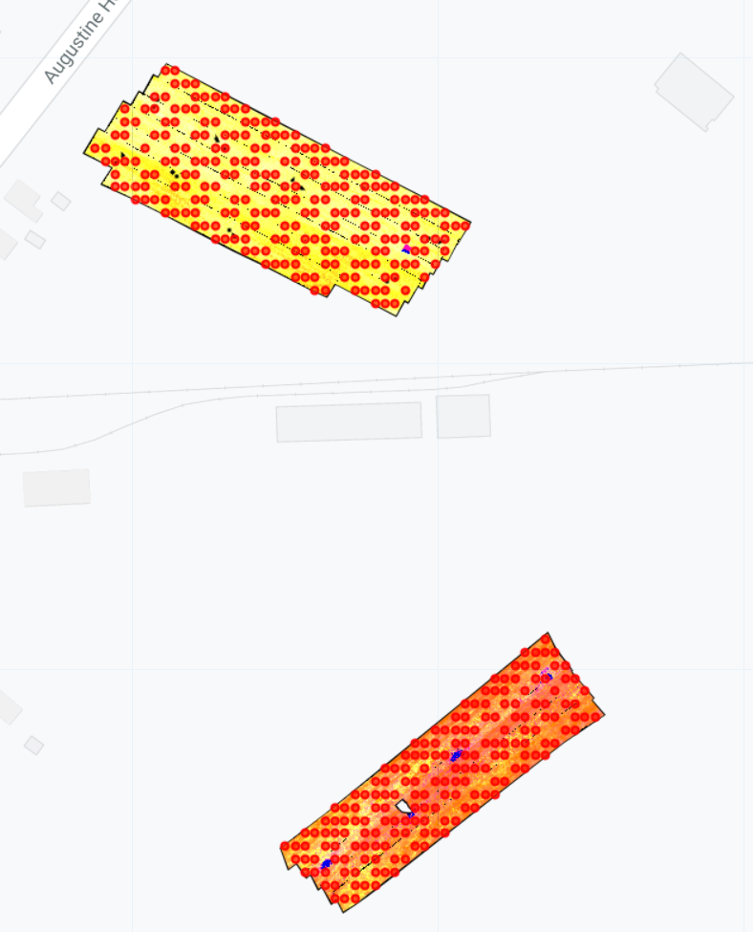

Figure 25.

Once samples have been accumulated, the next process was to use the level 1 model (hyperspectral model) to estimate biomass and nitrogen values for the accumulated samples. A random forest model was built in the same manner as in task 2.2 but the parameters for the model were set to that of which the USDA used in their hyperspectral model implementations. Number of trees set to 415 and the number of variables per split set to 18. The dataset to train the model was also the same used by the USDA which has the 16 quadrat elements of biomass and nitrogen values combined with the aggregated hyperspectral band data that resides at thet quadrat locations. This dataset trained the biomass and nitrogen random forest regression models, then the trained regressors were applied to the sampled points on the two fields to result in a large collection of estimated biomass and nitrogen datapoints. The full script/code for this process of accumlulating the estimated dataset is available in section A.. . The low level to high level modeling strategy is outlined in **Figure 26.**

Figure 26

With the large dataset of estimated field values, two new models were produced to predict nitrogen and biomass. Prior to training the model, a short preprocessing script was necessary to link the sentinel imagery to the locations of the sampled points. The code for this script is available in section A___. The output of the code are two datasets, each consisting of 405 samples for field estimates of biomass and nitrogen.

### Implementation of Subtask 4.2

Output from task 4.1 gives datasets for biomass and nitrogen estimations from a hyperspectral random forest model; one dataset contains sentinel band values with biomass estimates and the other are the same band values but with the nitrogen estimates. When split into training and validation sets the number of samples for training is 308 and the number of validation samples is 97. The sentinel random forest regression models for biomass and nitrogen predicitons were developed in separate scripts. The biomass model building and test produced the results outlined in Figure 27.

FIGURE 27

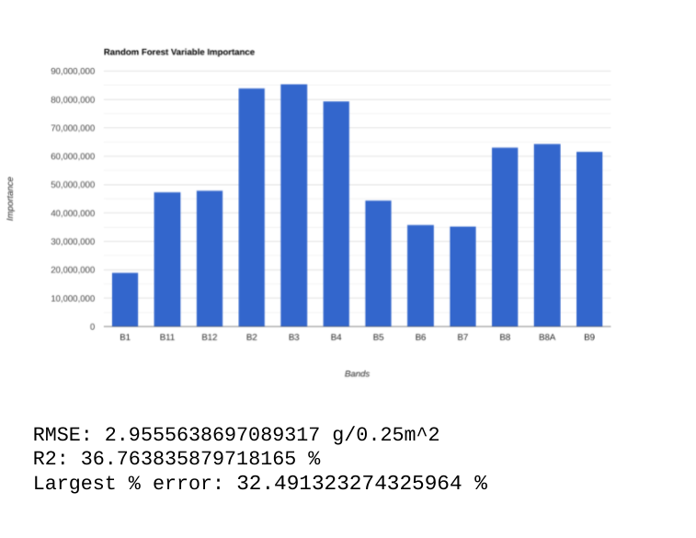

What can be observed as obvious improvements is that the R2 and RMSE values are both improved in the validation test for this new model. In comparison to the original model trained on only field level data where the performance was an R2 of 2.865% and RMSE of 16.639 g/0.25m2 . As explained in Task 2.1 the higher the R2 value is the better the prediction from the model proves to be where as a lower RMSE leads to be better model showing a minimizing in error from predictions. This intial result has confirmed that increasing the dataset gives the higher level sentinel 2 model to gain more of an understanding of the data to make better estimations. The newest performace metric added was the largest percentage error which takes the percent error of each individual sample from the validation set then compute which prediction had the largest error. This largest error experienced in the validation set was 32.49 %. Though these results are better they do not achieve the criteria for a successful regression algorithm.

In comparision the Nitorgen model was also trained on the new larger dataset and the results are shown in **Figure 28.** As was the case with the new biomass model, the R2 and RMSE performances improved with the new dataset. A comparison between the biomass and nitrogen models can be made in the case of the R2 and largest percent error metrics but not RMSE as it evaluates the error and is dependent upon the distribution of the value being predicted upon. Biomass values tend to have values ranging from 20 – 65 g/0.25m2 whereas the Nitrogen values tend to range between 0.1 – 1.1 g/0.25m2 the difference in scale and range for these values doesn’t allow for the RMSE metric to be comparable between the two types of random forest models. However the RMSE can be used to evaluate varations made within each respective model to determine the best iteration of a model.

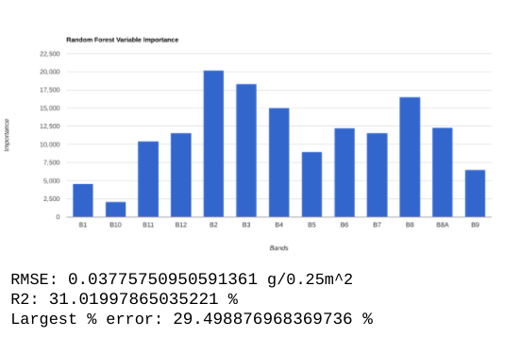

**Figure 28**

**Table 5** displays the original nitrogen and biomass models against several iterations of the new models with varying number of trees parameter. Table 5 shows that altering the number pf trees parameter has very little affect on the performance of the models at this point. Though increasing the size of the dataset brought better results, secondary refinements are needed to meet design criteria.

|  |  |  |  |  |  |  |  |  |
| --- | --- | --- | --- | --- | --- | --- | --- | --- |
| Seed=0 | Original models | | Large Data models | | | | | |
| Number trees | 300 | | 300 | | 400 | | 500 | |
| Model: | Nitrogen | Biomass | Nitrogen | Biomass | Nitrogen | Biomass | Nitrogen | Biomass |
| R2 (%): | 2.931 | 2.875 | 31.364 | 36.99 | 31.00 | 37.20 | 30.79 | 36.80 |
| RMSE (g/0.25m2): | 0.324 | 16.661 | 0.038 | 2.950 | 0.0377 | 2.945 | 0.0378 | 2.955 |

Table 5

### Implementation of Subtask 4.3

The secondary refinement outlined in task 3.3 is an inclusion of vegetation index formulas with other bands. This will boast the use of several bands sensitive to vegetation rigor into a single variable giving the random forest model additional predictor variables to train on. Sentinel hub provides a collection of the vegetation indices formulas that directly use the sentinel 2 bands for computation [14] . The whole collection holds 50 vegeation indices, integration of all indices may add noise into the model with variables that hold little importance in making predictions. Choice of the selected vegetation indices for inclusion to this refinement process were based on their use within other applications of remote sensing analysis with sentinel imagery and recommendations from the USDA research team. The indices of choice were NDVI, EVI, AVI, ARVI, and CVI.

In order to implement the index formulas into the dataset a script was produced that applies the formula as a mapping function to the original datasets. The ‘map’ method is built into the GEE javascript library to act as an iterative loop within the code editor. The method is applied to feature and image collections and loops through each element in the collection and exports a new collection with each element modify based on the specified computation enacted inside the mapping.

The formula for each index was accessible in the collection in javadscript format with the proper band names labeled. The expressions were integrated into functions in the GEE script that extract the feature element from a collection then selects the necessary bands from that element to input to the expression and output from the function is the new feature element with the added vegetation index as a new band. An example of the function from the whole index adding script is shown in Figure 29. The entire script for adding new indices to the dataset is available in **section A[]…** .

FIGURE 29

With the new indices added to the feature collection, this new dataset will be implemented into the two random forest models to assess new performance for predicting biomass and nitrogen.

### Implementation of Subtask 4.4

The new dataset with added vegeation indices now has 16 predictor variables to be trained on by the two models. As it is custom to have the number of variables per split to equate to 1/3 of the total number of variables this parameter will be increased from 3 to 5 and the number of trees kept at 400. With the number of training and testing elements kept constant at 308 and 97 respectively, the last change made before implementing this refinement was allowing the model to look for the specific index band names within the dataset while training.

The initial results of the added vegetation index refinment for the biomass and nitrogen regression models can be viewed in figure 30 and 31 .

It can be seen that the addition of vegetation indices as **training varaibles has….. the model**. **In the case of the biomass model…. While in the case of the nitrogen model …..**

**By looking at the variable importatince graphs it can be seen that the veg indexs rank ….. compared to the original sentinel bands. This shows that the new indices are being used ….(more or less)** than the original bands in the new models.

Further investigation was performed to evaluate the true effect of each vegetation index on the model performances. **Table 6 and 7** show the result of training each model with differing combinations of vegetation indices.

**It was concluded that the most effective combination of variables to train the model was …..**

### Implementation of Subtask 4.5

The full dataset of field level quadrat points has been processed by the USDA. This new larger dataset contains … total elements of quantisized field data. …. elements were data points collected in spring and … were datapoints collected in winter. Quadrat locations range from three farms spread across eastern Maryland diversifying the data beyond one field as has been the limitation if the dataset up to this point. The new field data differs from the original dataset as the units for measuring biomass and and nitrogen were aletered. The new data records biomass in Megagrams per hectare (Mg/ha) and records nitrogen in kilograms per hectare (kg/ha). Hectares are commonly used units in agriculture when quantifying large scale fields. 1 Hectare is equivalent to …. .

The new dataset was uploaded and processed in similar manner as the original quadrat dataset. Once imported as a new feature collection, the dataset had to be linked to the sentinel imagery at the correct time periods the data was recorded from. The new data was separated by the month it was collected in and the farm the quadrats were collected from. Figure 32 displays the loactions of the fields that quadrat data was sampled from. A new script originating from code in section A… (the code to combine sentinel and quadrat data) was produced to link the correct sentinel pixels to the correct quadrats based on location and time period. The processed collection of data points can now be implemented into new nitrogen and biomass models.

Figure 32. show the location of the eatern shore farms( zoomed out )

The new scripts from biomass and nitrogen model version 2 is available in section A…[]. Each model will be initialized with the original parameters expressed in task 2.3 with number of trees set to 300 and variables per splits set to 3. With the 70-30 split, the number of training samples from the enire dataset was …. And the number of validation samples was…. . the initial results for each model are shown in Figures 33 and 34 .

The field level quadrat data comes from two very distinct time periods playing a significant role in the quality of data predictions therefore the dataset was split and training models were produced for each time period.

### Implementation of Subtask 4.5

**** discuss the take aways from each refinement individually, then how they compare, how they can possibly be integrated with each other, then make the integrations and present table of model performances (i.e. a model trained on one dataset must perform well on its validation data and the set of data from the ground truth (field level ) dataset) adjust the seed value 10 times for each best model from previous refinments and compare****

## Implementation of Task 5.

Task 5 begins to accumulate the separate scripts of code to form the baseline of the application. The fundatmetal requiremnets for the tools functionality are developed initially to ensure fidelity with multiple runs of the application. The modeling refinement comes to a close as the final adjustments were made to the regression models. The highest performing iteration of each model was selected and integrated into the applications base script.

### Implementation of Subtask 5.1

### ****select the best models per iteration/refinement versions (the very best models)

### Task 4.6 provides the overall list of differeing model iterations. In total …. Models iterations were produced. Task 5.1 involves applying the best possible evaluation process to each model iteration. The evalution process is to test each model iteration against different sets of ground truth field samples. The sets of samples consist of 3-site spring samples, 3 -site winter samples, 3-site combined spring and winter samples. Table 9 displays how each model iteration performed against the final evaluation process. Section A{} holds the code for reproducing the investigation

Table 9

Results from Table 9 show that the models trained from field level data samples (field-data models) perform the best across the three evalutions in comparison to the models trained on the large estimated dataset (simulated-data models). Among the field-data models

Due to the results presented by the final evaluation tests. The model that will be implemented into the application code will be the…..

This model version gives the best overall performance and meets the criteria set in design requirements.

### Implementation of Subtask 5.2

The base code for the complete application is initiated in task 5.2 first by combining separate scripts of dataset preprocessing and model building. The base functionalities of the application are automatic subsampling, band extraction and model predictions. These functionalities have been developed in separate scripts for previous tasks. The required code available in sections A, A, and A… . With some alterations the combination script (available in section A[]) (take code form the advanced_app_ver code in GEE) takes a defined shapefile, samples points across the polygonal boundary, extracts sentinel pixel bands at each point and makes a random forest regression estimation for both biomass and nitrogen for each smapled point.

Due to the limitiations experienced in the GEE code editor platform, fully trained regression or classification models can imported to a new script. For this reason any new regression estimation requires the biomass and nitrogen models to be inherently trained then applied to the samples in question. Therefore the data used for training both models needs to be packaged with the full application….

A secondary adjustment was made to add more training data to the modeln since a validation set wasn’t needed in the application code. It can be hypothesized that more training data leads to more accuracte estimations as was seen in previous refinements of the models. To ensure that inclusion of the valdation set into the training data further improved the model performance, the OOBE was used to evaluate the new model which is done throughout training. This metric, as expressed in Task 3.1 , is the error experienced when cross validating each tree of the random forest with each other, inherently perfoming a validation test mid training…

The results from the comparison of OOBE between new models with full training data and previous models with parital training data is expressed in TABLE …

The results of table/…. Show that the ….. model is best applicable to be utilized in training the models for the fully developed application. With the training datasets and model ahchitecture decided, the final functionalities for the baseline application code were developed.

### Implementation of Subtask 5.3

An arbitraury field from an unseen location was selected to display the current function of the baseline code.

The fields name is the Rider farm ….

**** *talk about the investigation and prediction on the rider farm with pictures,*

*\*\*\*\*\*\*talk about revisions made ot the base line script ( script advanced_app in GEE*

*\*\*\*\*\*\*\* talk about moving the baseline code into the official application script ( UI_test script in GEE*

## Implementation of Task 6.

Task 6 begins the final design requirements to be met for the project. The User Interface functionalities are developed, tested, refined and integrated into the full application. The 4 major interactive functionalities for the application would be adjusting the target field geographical location, selecting the time period of satellite imagery, defining the modifiable field boundary, and reviewing the biomass/nitrogen estimations visually on the map.

### Implementation of Subtask 6.1

Earth Engine provides access to client-side user interface widgets through the ‘ui’ package. This package allows graphical interfaces to be contructed for Earth Engine scripts. [16] The first goal of implementing UI elements to the application is defining the visual layout that will hold the various top level widgets and features for the app. The interface controling the layout of UI are panels within the ‘ui.()’ package.

Below the horizontal bar in the code editor holds all instances of ui panels and widgets as shown in Figure ..[]. The fixed instance that all further panels and widgets are built on top of is ‘ui.root’. By default one widget is contained in the root bein the ui.Map, as used in previous tasks to visualize field boundaries and satellite imagery.

Figure …

The app layout consists of two major panels with added interactive widgets contained within these panels. The first panel is the Map panel with holds the satellite imagery, geometry drawing for the filed location, prediction maps and visual layer control. The second panel is the inspector panel which is set to the side of the UI holding sampling button, prediction initialization button and prediction information.

Since the Map panel is by default part of the root ui, this was cleared and rebuilt. The ui.Map() was called resetting the Map and the inspector panel was created with a title and subtitle label included. The resulting panels are shown in Figure …[] . The interactive events and widgets part of app are contained within a function and called at the end of the script. The first widget included in the app function was a dateslider which a allows user input to change a rane of dates interactively. Using this widget in conjuction with the Image displaying functions allows the user to dynamically change the time period of imagery to present on the map. Most widgets available within the ui package give the option to define an onChange callback which applies a new event in the script. Events are fired by user interaction with a widget or a programmic change to a widget and are intitalised with a callback function within a widget. onClick() and onChange() are the two callback functions used for defining the event to employ.

Two dateslider widgets were added to the inspector panel. The upper dateslider defines the start date that the time period will filter the full collection of sentinel images to. The lower dateslider defines the end date of the time period. Without any initial change the default map is has a layer of sentinel imagery where the time period is from the first sentinel image in 2017 to present day. As was completed in previous tasks the collection of images were merged into one image by mosaicking them based on mean() aggregation. That is the average band values for every pixel across the collection of images was computed to display on the map. By user interaction with the widget a proper time range could be selected for the analysis to begin. As shown in Figure…{} the sentinel image is doaplyed on the map based on the assigned daterange.

### Implementation of Subtask 6.2

The next major functionality of the application is to allow user definition of the test area for the predictions to be made. On top of the map panel there are a set of widgets utilized to defining geometries, geometry layers and visualization layers. As referenced in Figure…[] the drawingTools widget are located in the upper left corner of the map panel. The default settings of drawing tools allow the user to switch between drawing point, line, polygon, and rectangle geometries. To the right of drawing settings is display of the geometry layers. In this widget user has control over which geometry is displayed on the map. Any new geometry is added to the list inside the layers widget. To simplify the display screen for the application the drawingTools widget was rebuilt with only the polygon drawing setting. Any newly drawn polygon will automatically be added to geometry layer one.

FIGURE ….

Once field geometries are able to be drawn the imagery was clipped to said geometries. A function was produced that extracted the defined sentinel image and the drawn geometry then clipped the image to that geometry. This was possible due to the layers() module; all visual outputs presented on the map are held and listed in either the drawingTools (for geometric layers) or ui.Map ( for image/feature layers) widgets. The created function is set to take the first geometry layer and first image layer to produced the clipped image whenever a change is made by the user to the drawn geometry. This ensured that whenever the user wants to make and edits or addtiotions to a geometry the test area image is automatically refreshed and updated.

The final functionality produced in task 6.2 was the subsampling process to obtain training points across the teat field. The process was required to be dynamic so that a new set of subsampled points would be accumulated with every update to the field geometry. To accomplish this a button widget was utilized to hold the subsampling function. Whenever this button was activated the sampling function was processed and extracted points across the field area. Figure ..{} shows an example test area after being drawn and clipped. Inside the console area above the map it can be seen that a feature collection was produced from the sample points button which holds the band data for ….points accumulated within the test area. Due to limitations to memory and processing power available within the Earth Engine platform if too many points are accumulated a memory limit error may be encountered. To avoid this the scale parameter of the sample points function will be editable and a factor parameter was set to limit the number of samples that are made across an area. The baseline settings result in the following formula to estimate the number of samples being produced:

N = (A / s2 ) * 0.95

Where A is the area of the polygonal geometry, s is the scale for subsampling, and N is the number of samples produced. The scale parameter can be adjusted when necessary if the number of samples caused computational limit errors. The code for the reproducing dateslider widget, geometry drawing, and subsampling is available in section A…(UI test scrip tin gee)

### Implementation of Subtask 6.3

The largest user functionality for the application was to visualize the predictions of the random forest models on the map. This required conversion of vector data points to a raster image for display. In Earth Engine it is possible to perform point interpolation of feature collections which use numeric data stored in a property of each feature to estimate values at new locations outside of the features [] . The result is a continuous image of interpolated values.

There are two major forms of interpolation utilized in remote sensing applications; Inverse Distance Weighted Interpolation (IDW) and Kriging.

IDW is ….. []

Kriging is …..[]

IDW ia a deterministic method nd use mathematical functions for interpolation while kriging is a geostatics method which relies on both statistical and mathematical methods. Also Kriging is most appropriate when spatially correlated distance or directionsl bias in the data is known.

Since the data sampled for predictions were evenly distanced points across the test field and statistical analysis of the predicted points will add further computational strain in the application, IDW was selected as the interpolation method.

The required parameters for applying the IDW interpolation to the predicted dataset are the mean, standard deviation, range of interpolation, and property to interpolate. To test its effectiveness, code from sectionA….( app_advanced script in GEE) was used to integrate the biomass and nitrogen prediction models into the application. The code for building and training the models were added to the application after the drawingTools function. The models are trained when the app is initialized, however actual predictions cannot be made until the field sampled points are accumulated. Therefore a new button widget was produced, labeled “make predictions”. This button only appears on the inspector panel once the “sample points” button is activated. When “make predictions” is activated the trained models are fitted to the sampled data points obtaining estimations for biomass and nitrogen.

In agriculture studies it is common to evalute percent nitrogen which is a computation of the percentage of nitrogen present per unit of biomass. This is used to easily compare the biomass and nitrogen estimations at each area in the field. The formula for calculating percent nitrogen from the predictions is as follows:

%N = (( N *1000 ) / ( B *1000000) )*100

Where N is a nitrogen prediction , B is a biomass prediction and %N is the percent nitrogen.

All three values were then interpolated with Earth Engines IDW function. The functions parameters of interpolation property, mean value, and standard deviation were all automatically computed once predictions are made. The last parameter for interpolating distance is left to be user defined. The code has this value set to the same distance as were used to aggregate sampled points therefore drastically reducing empty spaces in the interpolated image. Figure …{} shows an example of a interpolated raster image based on biomass predictions.

FIGURE …[]

Each interpolated image for biomass, nitrogen and percent nitrogen are added to the map as separate layers with a varying color scheme associated with each. This color visualization was vitally important to convey the models predictions as efficiently as possible. In Earth Engine visial parameters are needed to be defined when adding a new layer to the map. This required the minimum value, maximum value and display options. The minimum and maximum parameters clip the image to this range with any value below minimum set to the minimum and any value above maximum set ot the maximum. Once the range is defined the disply options determine how to visually show the data on the map. For satellite images to bands for display are selected clipped to the defined range and added to the map layers as was done for displaying the sentinel 2 image on the map. For the interpolated data since there are individual values for each point, a color palette was defined which is fitted to the data value range and evenly distributes the list of colors to the values within the range of minimum and maximum. It is much easier visually to compare an image with a coherent color scheme, meaning different shades of the same coloir can more effiecently show areas of high predictions vs low predictions. For this reason the Color Brewer online tool was used to determine a color scheme [color brewer ref]. hexidecmial codes can be used to represent shades of colors and the color brewer tool takes a desired color and creates and palette of those color shades. In the case of the predicted data, biomass was represented by green, nitrogen represented by blue and percent nitrogen represented by pink. Areas of high prediction yielded darker colors and low predictions yielded lighter colors.

A major obstacle was dynamically defining the minimum and maximum values for the visual parameters for each image. In Earth Engine the visParam argument for adding new images to the map layers requires the min and max parameters to be of type ‘int’ or ‘float’ Javascript values. This original problem was that computing the minimum and maximum values from the prediction collection gave outputs as Earth Engine Number objects which is just seen by the min and max parameters as an object and not real numbers. This hindered the ability to have the map visually change based on the distribution of the predictions. To fix this problem the .getInfo() function was utilized which extract the real value of an Earth Engine object to be used in client side operations. Now map produced by the predictions of the application is unique based on the area being processed giving an efficient visual distribution of the crop metadata across the field.

With this change now all base requirements for the application have been met, additional features were still needed to increase accessibility and efficienct of the application.

### Implementation of Subtask 6.4

The application now achieves all design requirements for the project. However design requirement 4 can be improved upon to give the user an easier experience with the application.

The first change is the layout of the panels. With panel size fixed it could hinder visability of he map therefore the information/inspector panel and the map panel were adjusted to be split side by side. As shown in Figure …[] this alteration allows the the panel sizes to be adjusted in unison.

Figure …

The next alteration were color bars to act as a legend to show how interpolated maps directly compare with prediction values. A color bar is added as a ……

The last alteration was the organization og the app functionalities. The list of widgets on the inspector panel tended to run into errors with the added functionalites when multiple updates to the samples area. Therefore the order of widgets in the panel were fixed and whenever an update took place the widget set to be updated only was affected on its specific section in the panel. With this final change the application was ready to be applied to a field to view its results. The field site used for displaying use of the application was the Meadowview farm in Eastern Maryland. The field in question is known to have cover crop growth similar to the crop used in training the random forest regression models. The steps to utilize the application are present below:

1. Access the application via the Public Access link which brings the user to the main interface in the default browser of the users computer

2. In the main interface of the application as shown in Figure…[], the user can control aspects of the displayed layout. The divided map and inspector panels can be adjusted left and right, the map can be zoomed in and out (seen in box 1 from Figure…[]) , the geometry of the field can be drawn with drawing tools ( seen in box 1 from Figure..[]) and the layers of rasters can be selected wit the layers tool (seen in box 3 from Figur..[]).

3. The location for field investigation can be selected quickly in the search bar (seen in box 2 from Figure …[]) a convientent format for defining field location is inputting the longitudinal and latitudinal coordinates for the field site into this bar.

4. With the field location defined, the time period for investigation can be selected with the date begin and date end sliders (senn in box 4 in Figure …[]). For this investigation dates between March 1, 2020 and March 31, 2020 were selected for this fields imagery.

Figure ….[]

5. After imagery has been selected the official field outline can be drawn with the geometry drawing tools ( seen in box 1 in Figure …[]). Geometry for the meadowview field has been produced in Figure []. Once geometry has been drawn, the sample points button can be activated to clip the imagery to the geometry and begin the sampling process. The clipped image is then added as a layer to the map layers widget (seen in box 3 in Figure..{}) . Activating the sample points button also displays the make prediction maps button in the inspector panel.

Figure…[]

6. The make prediction maps button should be pressed next to activate the random forest models within the code and make estimations for each sampled point across the field geometry. As shown in box … from Figure…[] the estimations are displayed as new map layers where their visibility can be controlled. Along with each map estimate is a corresponding colorbar legend (seen in box… from Figure[]). Additionally the minimum and maximum values for biomass and nitrogen estimations are displaye in the upper section of the inspector panel (seen in box… form Figure[]) . This ends the basic functionalities of the application.

Figure…[]

7. Optionally, with a possession of a Google Earth Engine account, a user can access a copy of the full source code for the application. This gives the user modification ability of the code to alter parameters such as, limit to number of samples, sample distance, interpolation distance, and color of estimation maps. This Source code version of the application can be accessed by a code snapshot link. This link can generated at any point from the base code editor of the Earth Engine platform and just records the current state of the code within the editor.

8. the Final major feature of the application that is accessibile through the full access code is the ability to inspect the map layers. As shown in Figure….[] the inspector is accessed in the code editor on the upper right page beside the console. When any location is selected with the cursor the band values from all images in the map layers are presented in the inspector page. This allows for the biomass, nitrogen and percent nitrogen estimates to be explored at exact points across the field.

Figure..

The link for the Official Application accessible by any user with a browser is available here: <https://rileytim413.users.earthengine.app/view/covercrop-biomass-and-nitrogen-estimator>

The link fot the Full Access code of the application is available here:

### Implementation of Task 3.

Task 3 is the beginning of writing the code for the app functionality. The app will be written and published within the Earth Engine Javascript API. The most basic functionality of the application are the objectives of task 3, which will be the prompts from the app to the user. First asking for a location coordinate and to use that input to display imaging from the Sentinel-2 surface reflectance database of the location. Then asking for confirmation to use the location displayed to be captured and analyzed to produce plant health predictions.



#### Implementation of Subtask 3.1

The earth engine javascript API comes equipped with libraries of functions that perform native Javascript actions as well as functions to analyze, interpret and process geospatial raster and vector data. To accomplish the objective of task 3.1 (initiating the applications user interface) the native Javascript libraries were at play along with a specialized library built towards providing App style interaction (ee.ui). The original satellite map of the code editor is actually a default output of the ui.() library and when the functions are called upon to perform further interface related actions they are printed on top of the map area of the code editor. To begin the task of connecting the user to the application an action for the script to ask the user for an input was developed by using the prompt function. When used in the code editor the result is shown in Figure 12

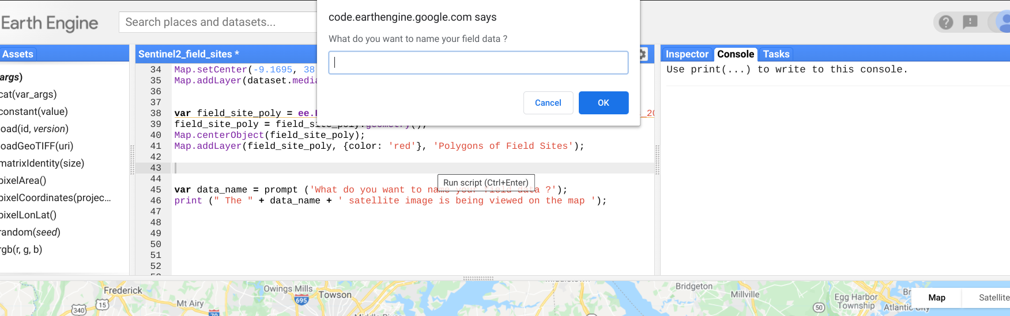

Figure 12: Prompt from Earth Engine code asking for field data name.

This is just the basis for the prompts that the application will display to the user. Other prompts produced will be for coordinates, algorithm activation, and raster map exporting. The Sentinel-2 satellite database was written to be imported to the code of the application ( source code for this process shown in **section A2**  of the Appendix) . Once the prompted question is answered the program displays the satellite data onto the map. This represents basic operation of the application, prompt and visual response. Although it was found that the ui function library within the API was useful for adding another element of cohesion and interaction between user and program.

To begin implementation of the ui interface in the application script, it was necessary to understand the language and syntax of javascript. Three vital concepts for production of a capable ui program were ‘variables’, ‘functions’ and ‘objects’ in javascript. Functions in Javascript are blocks of code designed to perform particular tasks and is executed when something calls upon it. A variable in Javascript is a container for data values. A function is defined with the ‘function’ keyword then is followed by a name for the function then followed by parentheses () the names within the parenthesis represent the parameters to be used within the function. the code to be executed as part of the function is contained within curly brackets{}. An object in Javascript is similar to a variable but objects contain many values which give the object multiple attributes. An object is defined in the following syntax:

var object1 = { name1:value1 , name2:value2, name 3:value3}

#### Implementation of Subtask 3.2

The first functionality of the application would be for the user to specify the location that they would like to be shown on the map. When provided with longitude and latitude coordinates the script uses the MapCenter function to show the field location in the console map. Figure 13 displays the prompt from the Earth Engine spript to the user asking for longitude coordinates. After thr longitude is inputted to the scrip the user will be prompted to enter the latitude coordinates.

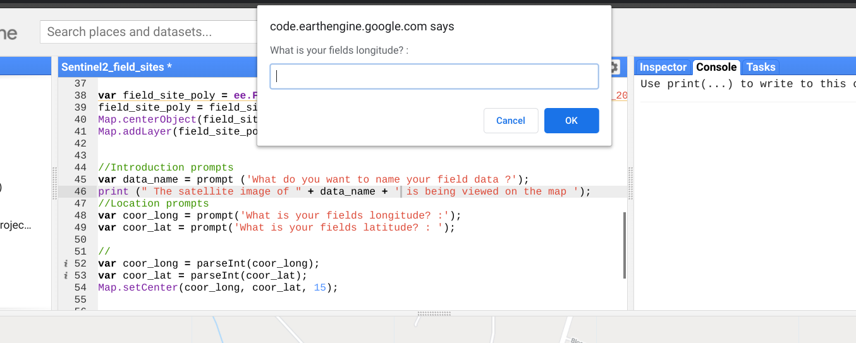

Figure 13: Basic UI for location finding functionality

The next step was to add this functionality as a UI widget where latitude and longitude have seperate input areas but perform as before and set the map to center on that coordinate.

#### Implementation of Subtask 3.3

The original design feature objective for subtask 3.3 was for the application to capture the satellite image of a certain location with given coordinates and geometry of area. But new ui libraries in Earth Engine allow for a more interactive experience so a different approach for task 3.3 was underway using the link map functionality. Instead of doing predictions/processing on still images and outputting resulting processed images, the application will be designed to show the normal RGB image of a field on one side of the map and processed image on the other. This allows a more interactive experience and comparison for the user.

The basic functionality for this design began with just displaying linked maps of displaying different bands from the satellite. This was done by adding a ui layer to the basic code editor map then attaching multiple panels to it with their own visualization parameter. Which displays the specified bands of the satellite image in that panel as shown in Figure 14. Each band has a wavelength and resolution that highlights different features of satellite imaging for example Band B4, B3, B2 show normal RGB imaging but B8, B11, B4 highlight differences between land and water.

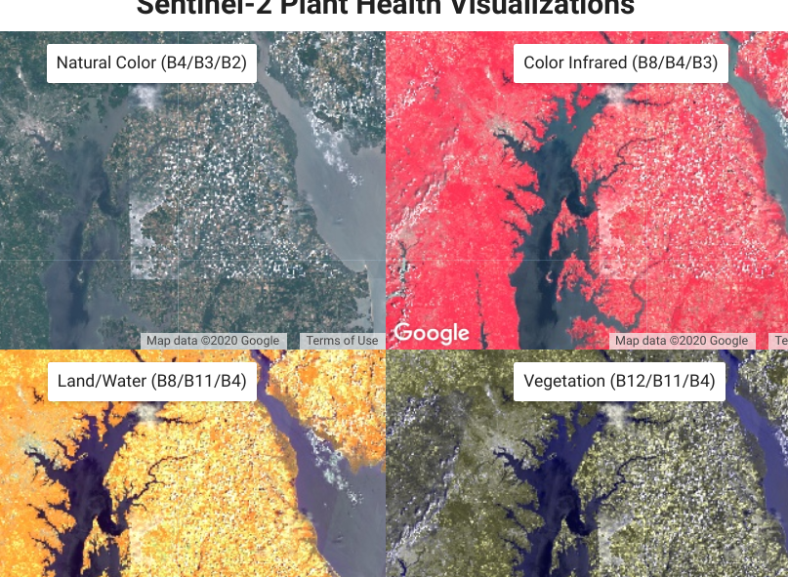

Figure 14: Display of linked map UI

The maps are also linked to each other in that when the RGB image is panned/moved with the mouse, the other maps also move with it still displaying their band imaging. The source code for producing this linked map ui is displayed in **section A5.**

### Implementation of Task 2.

Task 2 is the next major step in achieving the design requirements for the application, The Machine Learning Algorithm. Machine learning is an application of artificial intelligence allowing computational systems ability to learn and improve from experiences. A machine learning algorithm is the blueprint that's produced after a system is trained to process data. A system is trained to learn from datasets through models or structures that present the data to the system in various ways allowing the system to find and record patterns in the data to apply to a new set. There are multiple frameworks that employ machine learning and deep learning processes making the training process simpler on the data scientist. One of which is Tensorflow, an open source library for high level numerical computing. In this design Tensorflow will be used to produce a machine learning algorithm able to process and predict biomass content and % of nitrogen present in satellite pixels.



#### Implementation of Subtask 2.1

The First step in the general process of structuring any machine learning algorithm or deep learning network is defining the problem that needs to be solved. This way the important factors for development are defined like what the output should be and what the success metric should look like. In this case the problem is estimating metrics of biomass content and percentage of nitrogen on a very large scale. The desired success metric for the model should be 85%. The next step is identifying what the specific output of the model would look like, for example most models are for either classification or regression. Classification predictive modeling is the task of approximating a mapping function (f) from input variables (X) to discrete output variables (y) [diff between class and reg- reference here]. This basically means that the objective of the model is to analyze its input and use its trained weights to create a mapping function that is then used to assign a class or category to that input. Regression predictive modeling is the task of approximating a mapping function (f) from input variables (X) to a continuous output variable (y).[reffff] This means that the model will utilize its mapping function to quantize the input it is given or a numerical output. A classification output would be something along the lines of color like ‘blue’ or ‘red’ (a label). A regression output would be something like a cost estimation (a quantity). In the case of this design problem, this would need the implementation of a regression model to use inputs from satellite metadata to produce numeric predictions of biomass content and percentage of nitrogen.

The next process in developing a model would be to collect, prepare and preprocess the data. Done properly the quantity and quality of the data will determine how accurate the model can become. A ill preprocessed dataset will hinder the maximum accuracy the model can achieve no matter the qualities of the models structure. The machine Learning model training is dependent upon obtaining the accurate feature(x) and label (y) inputs of a dataset to produce a viable outcome. In the case of this design, the feature (x) input is the satellite pixel metadata/ band values and the label (y) input would be the biomass and % of nitrogen recorded at that pixel. Progress in training the model is halted by the current inaccuracy of the (y) dataset/ field level data. This factor will be solved with the updated and detailed field level data to come from the USDA soon.

This did not restrict development of the model's structure however. Machine learning and Deep learning are the two major subsets of artificial intelligence and each are used to solve ideal objectives. Machine learning is

associated with producing algorithms that allow systems to learn how to make decisions or predictions without being explicitly programmed. Deep learning is a subset of Machine Learning whereas it uses machine learning concepts and constructing algorithmic patterns similar to that of the human brain. The result are neural networks that can vary in layers and size but achieve high level understanding from complex data.

The USDA has previously worked on a similar design of a machine learning model that predicts biomass and percentage of nitrogen from hyperspectral drone images. The model algorithm achieved around 83% accuracy and the architecture of the algorithm was permitted to be altered for this design. The proposed Machine Learning algorithm will be a random forest regression model. This is a supervised learning algorithm that randomly creates and merges multiple decision trees into one forest.

Decision trees are a supervised learning method used for both classification and regression tasks. A decision tree is a flow-chart-like structure, where each internal (non-leaf) node denotes a test on an attribute, each branch represents the outcome of a test, and each leaf (or terminal) node holds a class label or estimation. Figure 15 shows a visualization example of a simple decision tree model.



Figure 15: Example of a decision tree flow chart.

Random forest regression is an ensemble tree-based learning algorithm.

Ensemble learning means strategically combining multiple models to accomplish a certain intelligence task.

It aggregates the votes from different decision trees to decide the final class of the test object. Regression refers to presenting a numeric output/prediction. Figure 16 shows a conceptual visualization of a Random decision forest model.



Figure 16: Visualization of a random forest regression model

The first objective of the model design will be to employ a random forest regression model similar to that used by the USDA to predict on the satellite data. The model inputs will be quantized features from the 12 band values extracted at each pixel in the satellite image. The model's outputs will be the average of biomass content and percentage of nitrogen predicted from the multiple decision trees. The structure of this regression model will be a tree ensemble method like that used by the USDA. tf.estimator is an API from the tensorflow library that will be used to train a gradient boosting model using decision trees. The model will first construct 300 trees, each split 12 times for each numerical band value and trained on around 200 indices representing each pixel from the satellite images. Once initial training results are obtained the model structure/parameters will be tweaked to achieve best results possible. If those results do not show to surpass 90% accuracy the focus will shift to producing a deep learning neural network model. This will provide a means for the application to achieve a higher level understanding from the dataset, provided that there is enough training data.

### Implementation of Task 1.

After some time further data was collected and processed by the USDA to be available to utilize within this project. The first dataset available was an example dataset useful for evaluating the way the training data of field level samples would look like and produce code that will process them properly. This synthetic data is presented as a table that has 72 elements representing the size and placement of the plot quadrats that will be processed and provided next.

#### Implementation of Subtask 1.3

The synthetic dataset is transferred to the local computer as a zipped folder holding files of shape file extensions. These shape files are uploaded to the Google Earth Engine code editor Assets. Once there the data is in the form of a feature collection as said before. The feature collection has geaometry and scalar values for each element so the data can be presented on the Map. Figure 17 shows the GEE (Google Earth Engine) Assets page and has the Synthetic Dataset asset highlighted in blue.

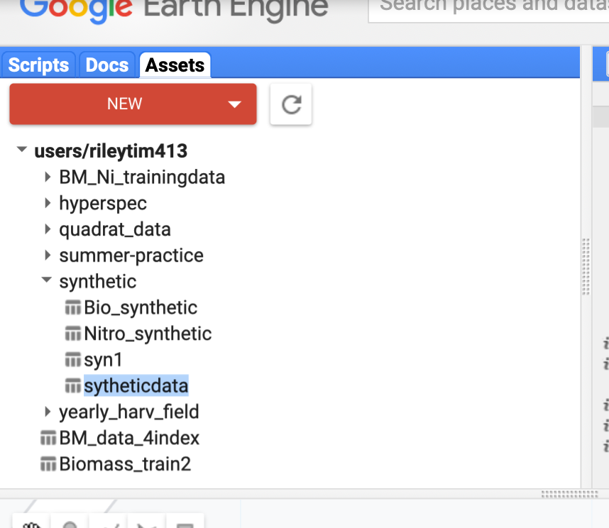

Figure 17: Directories housing data uploaded to GEE Assets.

Once the synthetic data is successfully uploaded to GEE Assets it can be manipulated in the intended way through wrting a new script. The first 7 features/elements of the Synthetic dataset table can be viewed in Figure 18.

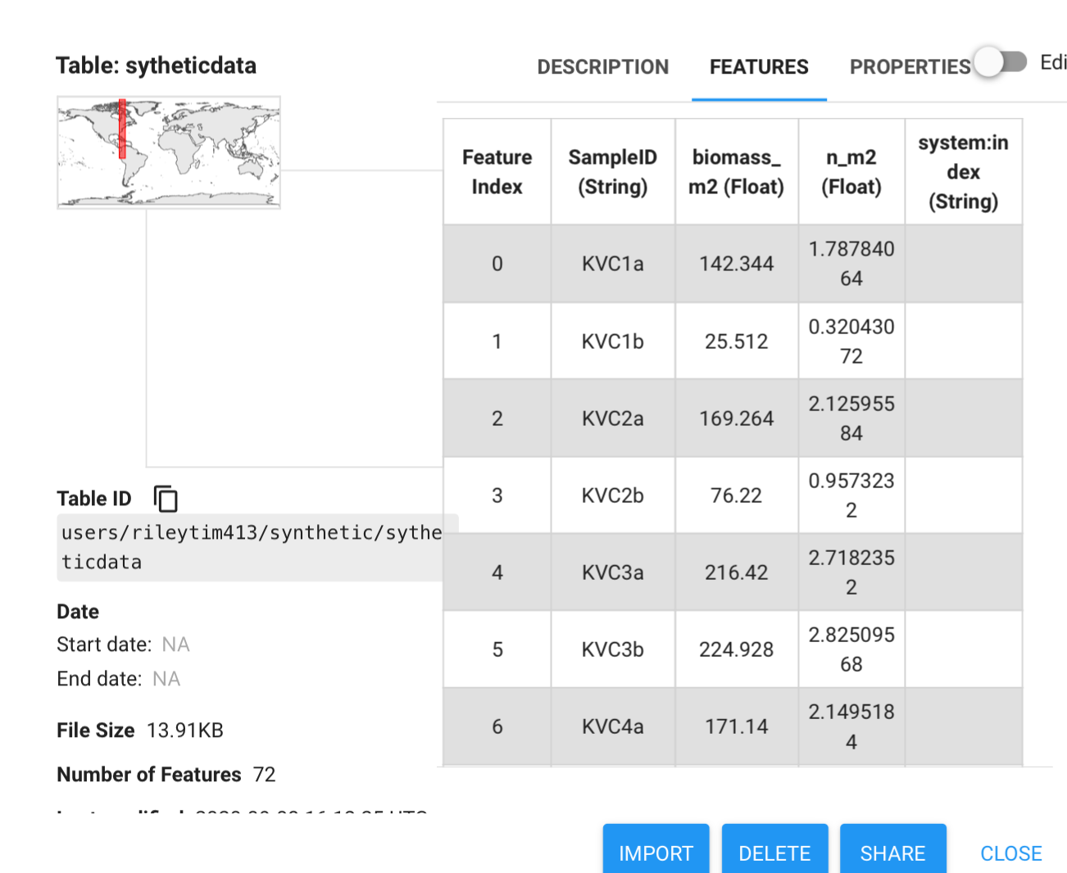

Figure 18: Synthetic Data table of biomass and nitrogen values

The data table has 3 major properties, the ‘SampleID’ representds a general location of where that specific feature was sampled from on the field, the ‘Biomass_m2’ is the biomass content that was collected from the samples, and similarly the ‘n_m2’ is the nitrogen content taken from the samples. The objectives of the next script codes will be to extract the the biomass and nitrogen from each sampled feature and return two separate datasets to be used for training a biomass prediction model then a nitrogen prediction model. This has to be done while also ensuring the location geometry of each sample is kept consist during extract to prevent a misleading dataset. This script, titled ‘organizing synthetic data’ , is meant to replace the code for extracting values from an excel sheet because this new script accesses the GEE asset directory for the feature collection data and keeps this data withtin GEE code editor to simplify the dataset preparation process. This code will take the location geometry of each feature element and add the longitude and latitude as a property in the table so that the location can be correctly associated with a satellite pixel in a separate script. Source code for this process is detailed in **section A7.**

#### Implementation of Subtask 1.4

Once it was determined that assigning location values as properties was possible the **section A7** code, the next step is to correlate the correct values of biomass and nitrogen to the pixel band values based on matching on the Longitude and Latitude coordinates. This is done in the source code in **section A8**  which builds on the code in **section A7** and **A4**  by first splitting the synthetic dataset collection into two ( one being the biomass values and the other being the nitrogen values), second a function is produced to clip the satellite image to each feature geometry in the collections, third the function will extract the band values at that feature location scaled up to the satellites 10m x 10m pixel area, and lastly the function will add those extracted band values as additional properties in each collection. Once those steps are completed the code will export the new biomass and nitrogen dataset feature collections to the GEE Assets directory to be used in training the machine learning Model.

After exporting the table of qudrat points with assigned Band values, the intial source code for developing a random forest machine learning model was produced (referenced as RF model).

---Problems with using synthetic data:

The production of this initial RF model source code was beneficial to testing the streamline process of converting quadrat data from a shapefile to a training dataset for the model. The detriments to this process were that the model performance couldn’t be taken as fact because the data was synthetically created while the ground truth data was being rendered by the USDA.

--at the moment there were only 13 field samples of quadrat data for training

---introduction to hyperspec data and two model workflow process

--detailed description of two model process (visual)

--review of process from getting hyperpsec strips, combining, linking to qudrat polygons, sampling points across HypSPec rasters ,merging bands with estimations , running through HP RF model, linking result to sampled point locations, linking results to Sen2 bands values at those locations, running through the New BM and Nit prediction models (stress how initially the dates across a whole month was used---in later step show that that was a judgement error [after revisionof results/model improvements] and that the proper dates using a cloud removal process was a necessary step)

--intial results of two model process

--intro to mean error, std devia, and RMSE

--revision of results to improve performance

--new results/ best results of 2 model workflow

--Introduction of the R^2 metric for evaluating RF models

--R^2 results for the two model process

--reseons for low accuracy

--cloud obscurities

--flawed process of achieving high level understanding from estimated data of a preliminary model

-- data for preliminary model is only from a single field so not much cvariety in the dataset

--improvement one

New task list:

1 Datapreprocessing

-

2 Building model workflow

3 testing intial model

4 collecting and analyzing the results

5 make secondary models based on changes

6 combine preprocessing and workflow code

7 make a preliminary test on separate farm/field

8 introduce User Interface elements

-convert predictyions to visual raster

-…

-publish app

#### Implementation of Subtask 1.4

1. Project evaluation

In this chapter, please evaluate the performance of the solution completed in the project with the considerations of public health, safety, and welfare, as well as global, cultural, social, environmental, and economic factors. And please consider improvement suggestion for the future on the aspect.

1. Public health
2. Safety
3. Welfare
4. Global factor
5. Cultural factor
6. Social factor
7. Environmental factor
8. Economic factor
9. Conclusion

By the end of the project, conclude the project and your learning experience.

Please make sure you include the overall evaluation of the project and the **future plan** about how the project can be improved.

* Project summary

…

* Learning and practice experience

…

* Future plan (how to improve)

…

Acknowledgment

Additional assistance in working through this design project was provided by Ph. D. candidate in Geography, Yanan Xin and Dr. Paul Adler from the United States Department of Agriculture – Agricultural Reaseach Service .

Appendix

You can put reference info here, including i) specs of components used in the system, ii) source code (must be here but not in the body text), iii) CAD figures, etc.

1. Source Code.

#### Source Code of producing polygonal boundaries of field sites:

var field_site = ee.FeatureCollection('users/rileytim413/cover_crop_five_sites_2018');

var field_site_poly = field_site.geometry();

Map.centerObject(field_site_poly);

Map.addLayer(field_site_poly, {color: 'red'}, 'Polygons of Field Sites');

#### Source Code of importing and creating map layer of Sentinel-2 image dataset

* Function to mask clouds using the Sentinel-2 QA band

* @param {ee.Image} image Sentinel-2 image

* @return {ee.Image} cloud masked Sentinel-2 image

*/

function maskS2clouds(image) {

var qa = image.select('QA60');

// Bits 10 and 11 are clouds and cirrus, respectively.

var cloudBitMask = 1 << 10;

var cirrusBitMask = 1 << 11;

// Both flags should be set to zero, indicating clear conditions.

var mask = qa.bitwiseAnd(cloudBitMask).eq(0)

.and(qa.bitwiseAnd(cirrusBitMask).eq(0));

return image.updateMask(mask).divide(10000);

}

// Map the function over one year of data and take the median.

// Load Sentinel-2 TOA reflectance data.

var dataset = ee.ImageCollection('COPERNICUS/S2')

.filterDate('2018-01-01', '2018-06-30')

// Pre-filter to get less cloudy granules.

.filter(ee.Filter.lt('CLOUDY_PIXEL_PERCENTAGE', 20))

.map(maskS2clouds);

var rgbVis = {

min: 0.0,

max: 0.3,

bands: ['B4', 'B3', 'B2'],

};

Map.setCenter(-9.1695, 38.6917, 12);

Map.addLayer(dataset.median(), rgbVis, 'Sentinel II imaging');

#### Source Code of Clipping image data to field boundary

var bandVis1 = {

min: 0.0,

max: 0.5,

bands: ['B6'],

};

//importing field site boundary features

var field_site = ee.FeatureCollection('users/rileytim413/cover_crop_five_sites_2018');

var field_site_poly = field_site.geometry();

Map.centerObject(field_site_poly);

Map.addLayer(field_site_poly, {color: 'red'}, 'Polygons of Field Sites');

//creating site image clipping to field boundaries

var site_img = ee.Image(dataset.median()).clipToCollection(field_site);

//Map.centerObject();

Map.addLayer(site_img, bandVis1, 'field site images ');

#### Source Code of extracting pixel band values

var image = ee.Image(images.filterDate('2018-01-01', '2018-06-30').filterBounds(field_site).first().divide(10000))

Map.addLayer(image, {bands:['B4','B3','B2'], min:0, max:0.3}, 'image')

Map.centerObject(field_site_poly);

Map.addLayer(field_site_poly, {color: 'red'}, 'Polygons of Field Sites');

// values

// get pixel values within region using a given scale

var coords = ee.Image.pixelLonLat()

var values = image

.addBands(coords)

.reduceRegion(ee.Reducer.toList(), field_site, map.scale)

print(values)

#### Source Code of linked map UI

// Each map has a name and some visualization parameters.

var MAP_PARAMS = {

'Normal Imaging (B4/B3/B2)': ['B4', 'B3', 'B2'],

'Land/Water (B8/B11/B4)': ['B8', 'B11', 'B4'],

'Color Infrared (B8/B4/B3)': ['B8', 'B4', 'B3'],

'Vegetation (B12/B11/B4)': ['B12', 'B12', 'B4']

};

// Shared visualization parameters for the images.

function getVisualization(bands) {

return {gamma: 1.3, min: 0, max: 0.3, bands: bands};

}

/*

* Configure maps, link them in a grid

*/

// Create a map for each visualization option.

var maps = [];

Object.keys(MAP_PARAMS).forEach(function(name) {

var map = ui.Map();

map.add(ui.Label(name));

map.addLayer(dataset, getVisualization(MAP_PARAMS[name]), name);

map.setControlVisibility(false);

maps.push(map);

});

var linker = ui.Map.Linker(maps);

// Enable zooming on the top-left map.

maps[0].setControlVisibility({zoomControl: true});

// Show the scale

maps[3].setControlVisibility({scaleControl: true});

// Create a grid of maps.

var mapGrid = ui.Panel(

[

ui.Panel([maps[0], maps[1]], null, {stretch: 'both'}),

ui.Panel([maps[2], maps[3]], null, {stretch: 'both'})

],

ui.Panel.Layout.Flow('horizontal'), {stretch: 'both'});

// All maps will align themselves to this parent map.

maps[0].centerObject(table);

// Create title.

var title = ui.Label('Sentinel-2 Plant Health Visualizations', {

stretch: 'horizontal',

textAlign: 'center',

fontWeight: 'bold',

fontSize: '24px'

});

// Add the maps and title to the ui.root.

ui.root.widgets().reset([title, mapGrid]);

ui.root.setLayout(ui.Panel.Layout.Flow('vertical'));

#### Source Code of extracting excel sheet data

pip install openpyxl

import openpyxl

from openpyxl import load_workbook

%cd /content/

%ls

field_exel = load_workbook(filename= 'Spring_NBiomass_sample (1).xlsx')

sheet = field_exel.active

plant_health = sheet['Q1':'S9']

for c1, c2, c3 in plant_health:

print("{0:8} {1:8}".format(c1.value, c2.value,c3.value))

#### Source Code of assigning location geometry as a property in feature collection

//this function will calculate the center of the features geometry and add it as a property

var addCenter = function(feat){

var geocent = feat.centroid().geometry();

var centerProp = feat.set({location: geocent});

return centerProp;

};

var centerloc = synthetic.map(addCenter)

var center_geom = centerloc.geometry()

print(synthetic)

print()

print(centerloc)

// display the feature collection as a chart

var depData = ee.List(['biomass_m2','n_m2','location'])

//Adds polygonal boundaries of the feature collection outlined in red on the Map

Map.addLayer(centerloc.geometry(), {color: 'red'},'colored');

var one_location = centerloc.aggregate_first('location');

print(one_location);

Map.setCenter(-75.99249341711973,39.307373619426045,18);

print(centerloc.toList(15))

#### Source Code of producing training dataset from feature collection of biomass/nitrogen values

**var** table **=** ee.FeatureCollection("users/rileytim413/sytheticdata"),

table2 **=** ee.FeatureCollection("users/rileytim413/KV_pt1");

/***** End of imports. If edited, may not auto-convert in the playground. *****/

54//Satellite images and feature imports:

65{

76

87**var** dataset **=** ee.ImageCollection('COPERNICUS/S2')

98 .filterDate('2018-01-01', '2018-06-30')

109 // Pre-filter to get less cloudy granules.

1110 .filter(ee.Filter.lt('CLOUDY_PIXEL_PERCENTAGE', 20));

1211{

1312**function** cloud_mask(image){

1413 **var** qa **=** image.select('QA60');

1514 **var** cloudBitMask **=** 1 **<<** 10;

1615 **var** cirrusBitMask **=** 1 **<<** 11;

1716

1817 // Both flags should be set to zero, indicating clear conditions.

1918 **var** mask **=** qa.bitwiseAnd(cloudBitMask).eq(0)

2019 .and(qa.bitwiseAnd(cirrusBitMask).eq(0));

2120

2221 **return** image.updateMask(mask).divide(10000);

2322 }

2423

2524**var** dataset **=** dataset.map(cloud_mask);

2625

2726**var** RGB **=** {

2827 min: 0.0,

2928 max: 0.3,

3029 bands: ['B4', 'B3', 'B2']

3130};

3231

3332Map.addLayer(dataset.median(),RGB, "Sent II");

3433

3534}

36 **var** data **=** table2;

}

3837

3938// create centroid location from features and add as new property

4039{

4140**var** addCenter **=** **function**(feat){

4241 **var** geocent **=** feat.centroid().geometry();

4342

4443 **var** centerProp **=** feat.**set**({location: geocent});

4544 **return** centerProp;

4645};

4746

4847**var** data2 **=** data.map(addCenter)

4948

5049print('this is the orginal feature collection')

5150print(data)

5251//print("the added centroid example is below:")

5352//print(synth2.toList(4));

5453

5554Map.addLayer(data2.geometry(), {color: 'red'},'colored');

5655Map.setCenter(-75.99249341711973,39.307373619426045, 18);

5756}

5857

59 // create new feature collection from centroid location, and synthetic data info

58

{

61 **var** propList **=** ee.List(['biomass_m2','n_m2']);

**var** biomass_collection **=** data2.map(**function**(feat){

6363 feat **=** ee.Feature(feat);

6464 **var** loc **=** feat.centroid().geometry();

65 **return** ee.Feature(loc, feat.toDictionary(ee.List([propList.**get**(0)])));

65

});

var nitrogen_collection = data2.map(function(feat){

6869 feat = ee.Feature(feat);

6970 var loc = feat.centroid().geometry();

return ee.Feature(loc, feat.toDictionary( ee.List([propList.get(1)]) ) ) ;

71 });  
//print('this is the new collections with new geometries')

74

//print(nitrogen_collection)

7678}

7779

7880// Extract band values from SenII images based on centroid locations

7981// Add band values to the new feature collection as properties

8082{

8183 // this function extracts the band values from the feature argument based on its provide geometry coordinat

8284 // the band values are obtained from a pixel scaled 10 meters up from the Lat, Lon coordinate.

8385**var** extractBand **=** **function**(feat){

8486 **var** bands **=** ['B1','B2','B3','B4','B5','B6','B7','B8','B8A','B9', 'B10','B11','B12'];

8587 **var** num_elements **=** bands.length;

8688 **var** img **=** ee.Image(dataset.median().clip(feat));

8789 img **=** img.select(bands);

8890

8991 **var** valuesList **=** img.reduceRegion({

9092 reducer:ee.Reducer.toList(num_elements),

9193 geometry:feat.geometry(),

9294 scale: 10,

9395 }).values().**get**(0);

9496

9597 **var** el **=** ee.List(ee.List(valuesList).**get**(0));

9698 **var** addedBands **=** feat.**set**({

9799 B1 : ee.Number(el.**get**(0)),

98100 B2 : ee.Number(el.**get**(1)),

99101 B3: ee.Number(el.**get**(2)),

100102 B4: ee.Number(el.**get**(3)),

101103 B5: ee.Number(el.**get**(4)),

102104 B6: ee.Number(el.**get**(5)),

103105 B7: ee.Number(el.**get**(6)),

104106 B8: ee.Number(el.**get**(7)),

105107 B8A: ee.Number(el.**get**(8)),

106108 B9: ee.Number(el.**get**(9)),

107109 B10: ee.Number(el.**get**(10)),

108110 B11: ee.Number(el.**get**(11)),

109111 B12: ee.Number(el.**get**(12))

110112 })

111113 **return** addedBands;

112114}

113115

114116

115117

116118//@@@@@@@ read more on set() and features (i.e. set a geometry)

117119

118120}

119121

120122

121123// final training feature datasets

122124**var** biomassData **=** biomass_collection.map(extractBand);

123 **var** nitrogenData **=** nitrogen_collection.map(extractBand);

124 print('This is the training data collection with band values,')

125 print(biomassData);

126 print(nitrogenData);

#### 

REFERENCES

[1] Charles M. White, B. B. (2019). Predicting Cover Crop Nitrogen Content. *Agricultural & Environmental Research letters*, 1-4 .

[2] eudereka. (2019, November 26). *Data Science Introduction*. Retrieved from Eudereka: https://www.edureka.co/blog/decision-trees/

[3] Google. (2019, 09 14). *Developer guide*. Retrieved from Google Earth Engine : https://developers.google.com/earth-engine

[4] Google. (2020, March 04). *Introduction to Tensorflow*. Retrieved from Tensorflow: https://www.tensorflow.org/learn

[5] Kladivko, E. (2016). *Cover Crops for Soil Nitrogen.* Agronomy Department, Purdue University.

[6] M.J. Roberts, S. L. (1985). MEASUREMENT OF PLANT BIOMASS AND NET PRIMARY PRODUCTION. In *Techniwues in Bioproductivity and Photosynthesis* (pp. 1-19).

[7] United States Department of Agriculture. (2020, March 20). *Agriculture Technology*. Retrieved from United States Department of Agriculture National Institute of Food and Agriculture: https://nifa.usda.gov/topic/agriculture-technology

[8] W3 Schools. (2020, April 13). *Javascript*. Retrieved from w3schools.com: https://www.w3schools.com/js/js_objects.asp

[9] Walch, K. (2019, July 5). *How is AI Transforming Agriculture*. Retrieved from Forbes.com: https://www.forbes.com/sites/cognitiveworld/2019/07/05/how-ai-is-transforming-agriculture/#4203edd24ad1

[10]  [Asiri (2018, July11) .](https://medium.com/@sidathasiri?source=post_page-----a5cc4e1b0623-----------------------------------) *[Machine Learning Classifiers. Retrieved from:](https://medium.com/@sidathasiri?source=post_page-----a5cc4e1b0623-----------------------------------)*

https://towardsdatascience.com/machine-learning-classifiers-a5cc4e1b0623

[11] Pati, S (2021, August 3). *The Difference Between Artificial Intelligence And Machine Learning*.

Retrieved from: https://www.analyticsinsight.net/the-difference-between-artificial-intelligence-and-machine-learning/

[12] Ishwaran, H (2014, July 2). *The effect of splitting on random forests.* Retrieved from: https://link.springer.com/article/10.1007/s10994-014-5451-2

[13] Frost, J (2018). *How To Interpret R-squared in Regression Analysis.* Retrieved from: https://statisticsbyjim.com/regression/interpret-r-squared-regression/

[14] Sinergise (2019). *Sentinel-2 RS indices.* Retrieved from: https://custom-scripts.sentinel-hub.com/custom-scripts/sentinel-2/indexdb/

[15] Mapasyst (2019, August 21). *What does veetation index mean in remote sensing technology.* Retrieved from: https://mapasyst.extension.org/what-does-vegetation-index-mean-in-remote-sensing-technology/

[16] earth engine guides ui

[17]